**College of Engineering & Science**

**INDIVIDUAL ASSIGNMENT COVER SHEET**

|  |  |  |
| --- | --- | --- |
| **Unit Code:NIT3122** | **Unit Title:** **Enterprise Network Management** | |
| **Assignment Title / Reference: Assignment** | | |
| **Name of Lecturer / Tutor: Chen Guoqiang** | | |
| **Date Submitted:2023.11.29** | | **Contact Telephone No./ Email Address: sen.fang@live.vu.edu.au** |

## PLAGIARISM AND COLLUSION

**Plagiarism is ‘a practice that involves the using of another person’s intellectual output and presenting it as one’s own’**. This includes the presentation of work that has been copied, in whole or part, from other sources (including other students’ work, published books or periodicals, or unpublished works or unauthorized collaboration with other persons), without due acknowledgement.

## CONSEQUENCES OF PLAGIARISM AND COLLUSION

### A student found guilty of plagiarism will be subject to one or all of the following:

**Referral to Course Coordinator for:** counseling; submission of further work; use of the services of Student Learning Unit; the placing of a record of the alleged infringement on the student’s file.

**Referral of the matter to the Director of Teaching and Learning for:** issuing of written warning; re-submission of work for assessment or the undertaking of another form of assessment such as an oral or unseen examination; allocation of a fail grade to part or all of the assessment; allocation a fail grade to the unit.

**Referral of the matter to the Dean for:** suspension from the course; official disciplinary action by the University

### Disciplinary Committee.

**STUDENT DECLARATION (ALL STUDENTS TO SIGN)**

**HOW TO SUBMIT YOUR ASSIGNMENT**

I DECLARE THAT THIS ASSIGNMENT IS ORIGINAL AND HAS NOT BEEN SUBMITTED FOR ASSESSMENT ELSEWHERE.

I DECLARE THAT THIS ASSIGNMENT IS MY OWN WORK AND DOES NOT INVOLVE PLAGIARISM OR COLLUSION.

I GIVE MY CONSENT FOR THE ELECTRONIC VERSION TO BE EXAMINED BY RELEVANT PLAGIARISM SOFTWARE PROGRAMS.

I HAVE MADE AN ELECTRONIC COPY OF MY ASSIGNMENT, WHICH I CAN PRODUCE IF THE ORIGINAL IS LOST FOR ANY REASON.

NAME: __________Sen Fang______________ SIGNED: ___________Sen Fang__________________ DATED: _______________2023.11.29_____________

**HOW TO SUBMIT YOUR ASSIGNMENT**

# Students are required to submit their assignments to the relevant academic staff member via VU Collaborate. Students should ensure they are aware the due date.

A copy of this Assignment Cover Sheet is available from Student Forms: [www.vu.edu.au/student-tools/student-forms](http://www.vu.edu.au/student-tools/student-forms)

For more on assessment help and plagiarism: [www.vu.edu.au/student-life/getting-help/assessment-pr ogress-help](http://www.vu.edu.au/student-life/getting-help/assessment-progress-help)

**Task 1 – Active Directory Design** (6%)

• Design and draw the network **topology** based on the above scenario in your **Assignment_Your Name_YourID.docx**. Clearly label the server computer **names**, assigned **IP** addresses, assigned **domains**, and **DNS** IP addresses.

Important: When you start the lab, PLABDC01 must be powered on first. Please

note that some network services require Active Directory in order to function.

• PLABDC01 (Windows Server 2016 - Domain Controller)

• PLABDM01 (Windows Server 2016 - Domain Member Server)

• PLABDCORE01 (Windows Server 2016 - Domain Member Server Core)

• PLABSA01 (Windows Server 2016 - Domain Member Server)

• PLABWIN10 (Windows 10 Enterprise - Domain Workstation)

Lab Diagram

• Use commands **dates;ipconfig /all** to record the existing configurations, and take screenshots for each machine.

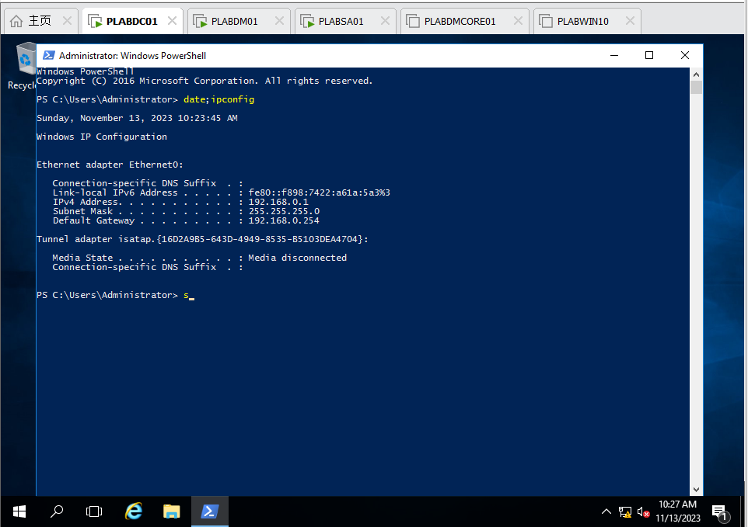

Figure 1 PLABDC01: Command date; ipconfig in PowerShell

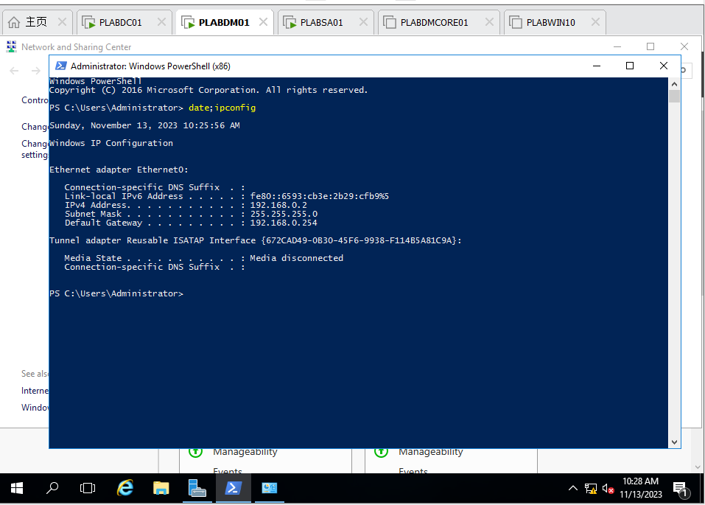

Figure 2 PLABDM01: Command date; ipconfig in PowerShell

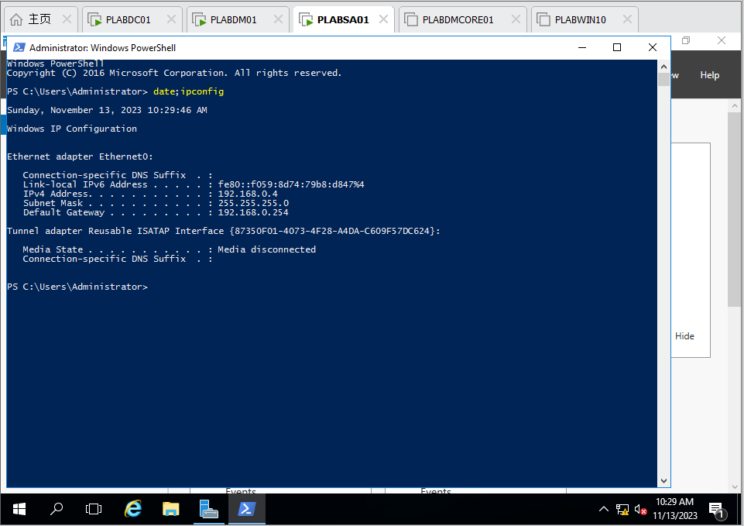

Figure 3 PLABSA01: Command date; ipconfig in powershell

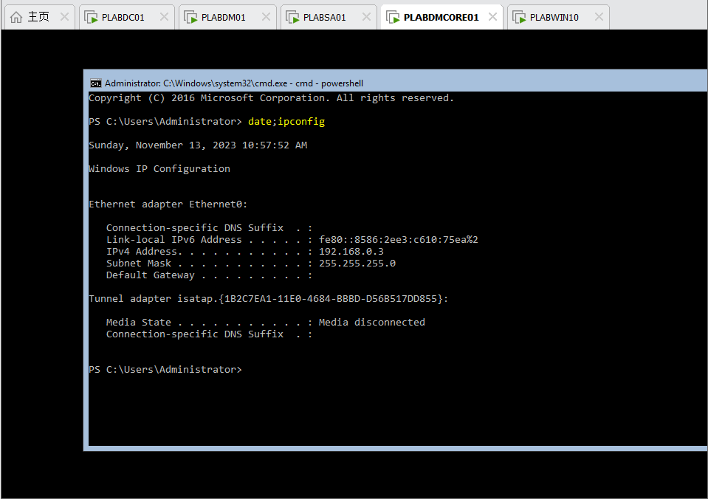

Figure 4 PLABDMCORE01: Command date; ipconfig in powershell

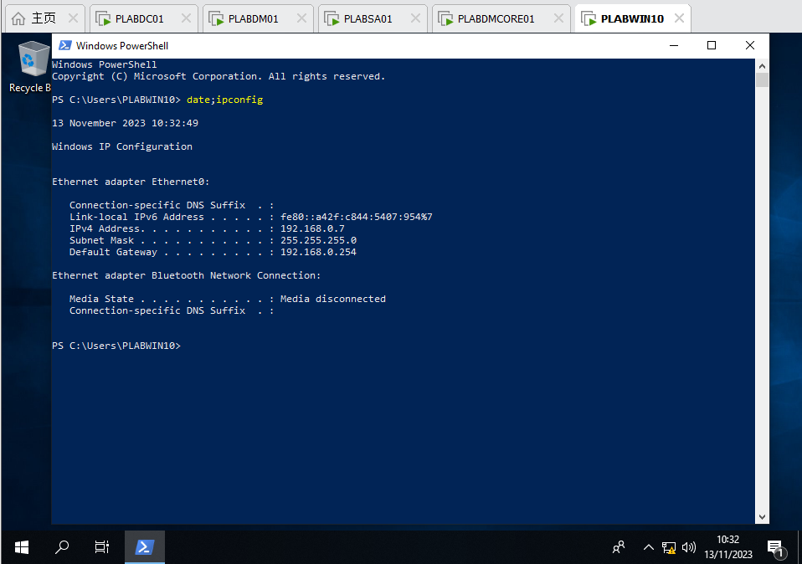

Figure 5 PLABWIN10: Command date; ipconfig in powershell

**Task 2 – Active Directory Installation** (9%)

• Configure the active directory according to the above design.

• Capture necessary screenshots to demonstrate the steps taken to configure the network, and provide some explanation for your steps.

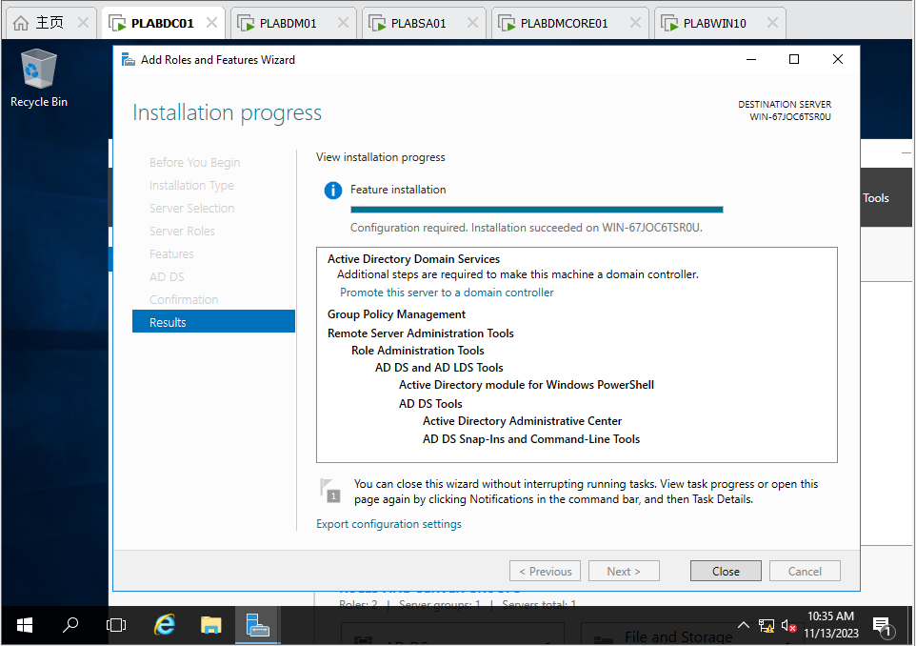

Figure 6 PLABDC01: Install ADDS (Results)

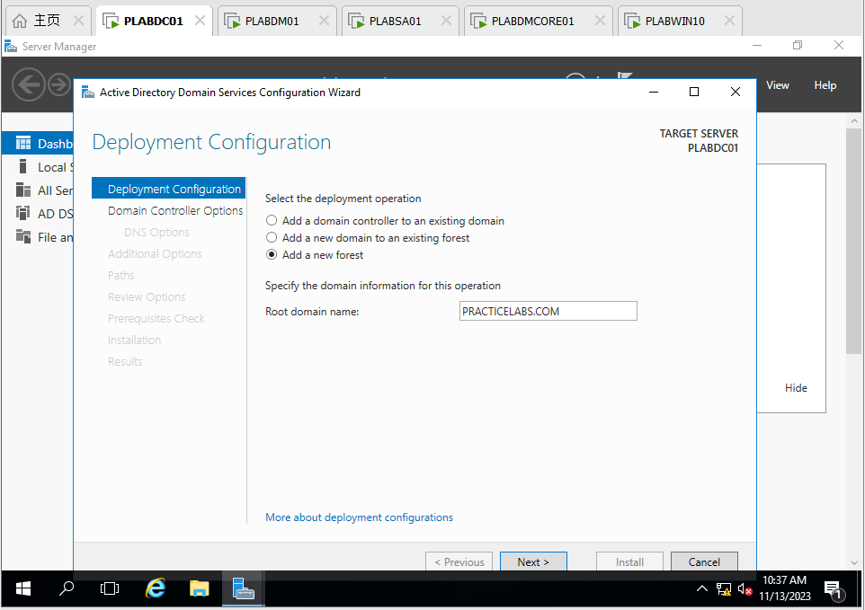

Figure 7 PLABDC01: Configure deployment operation and Root domain name

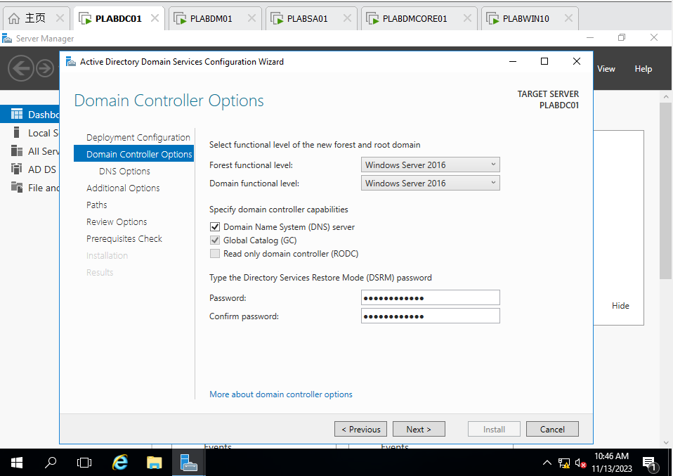

Figure 8 PLABDC01: Configure Password of DSRM

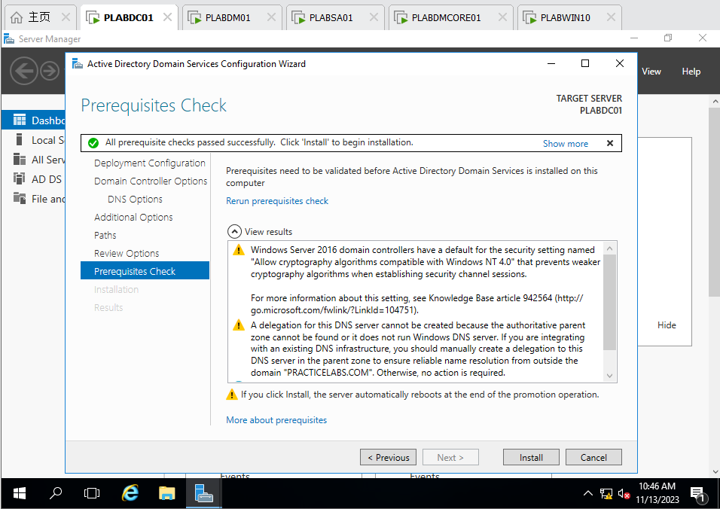

Figure 9 PLABDC01: Prerequisites Check of ADDS Service

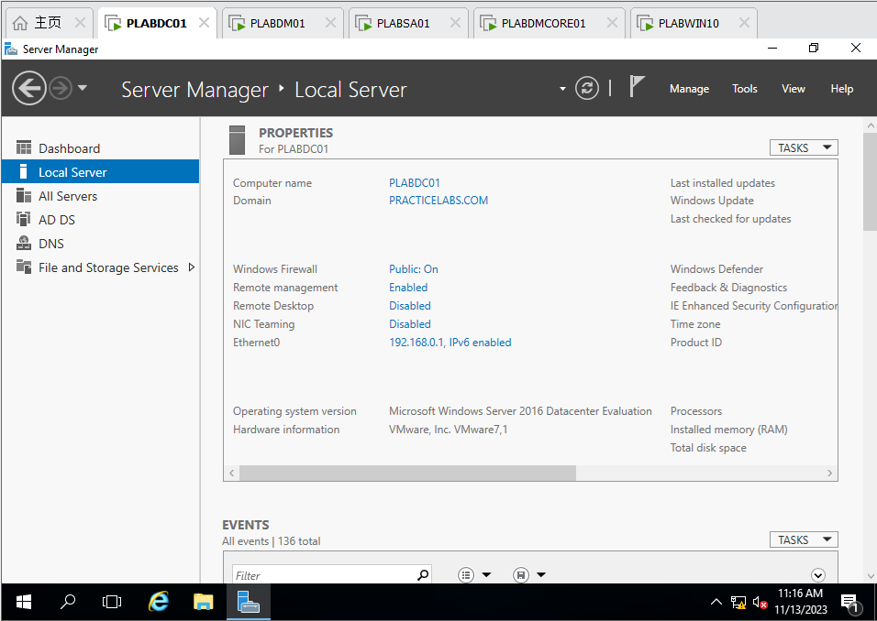

Figure 10 PLABDC01: Check the domain is done

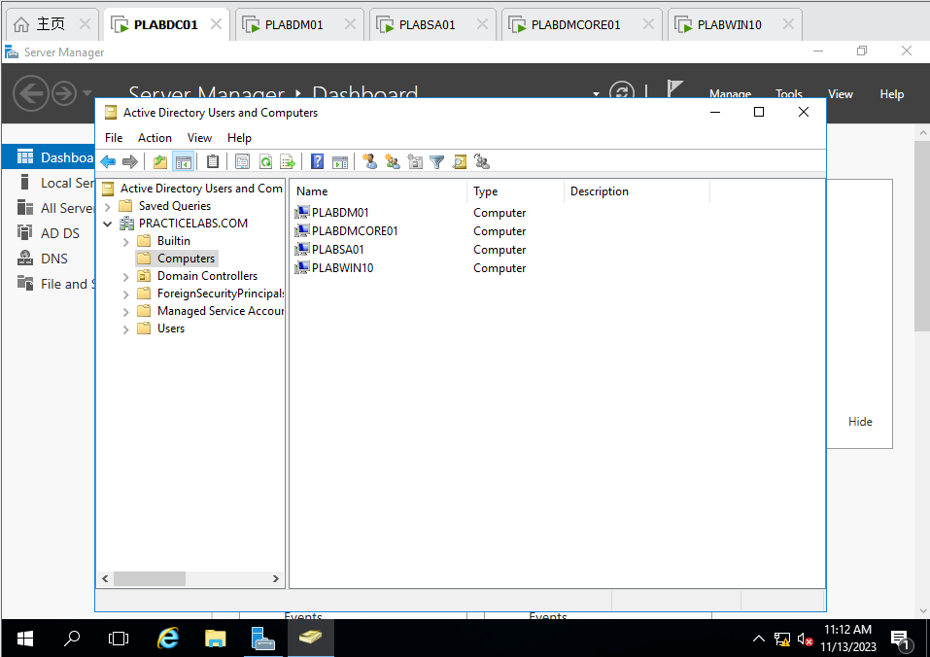

Figure 11 PLABDC01: Join *plabdm01, plabdmcore01, plabsa01, plabwin10* to the Domain

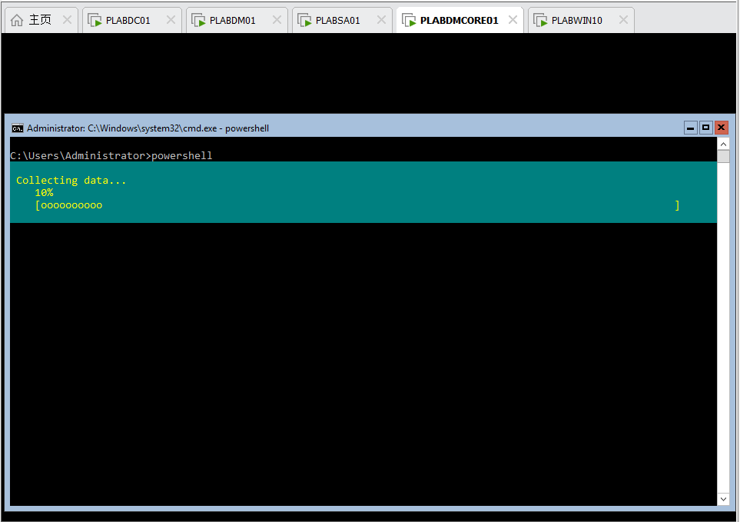

Figure 12 PLABDMCORE01: The progress of installing ADDS

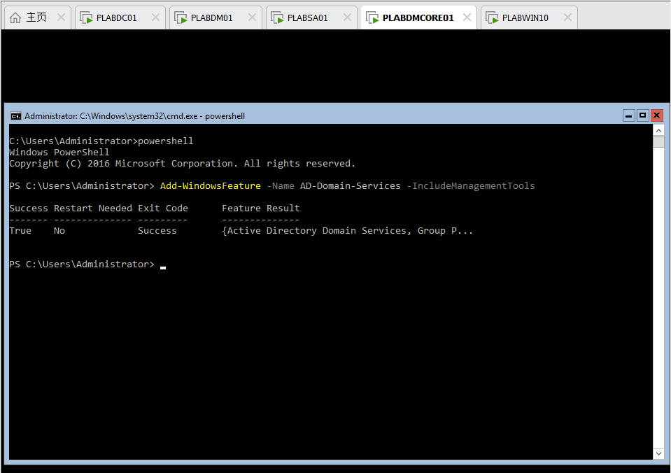

Figure 13 PLABDMCORE01: ADDS Installation is done

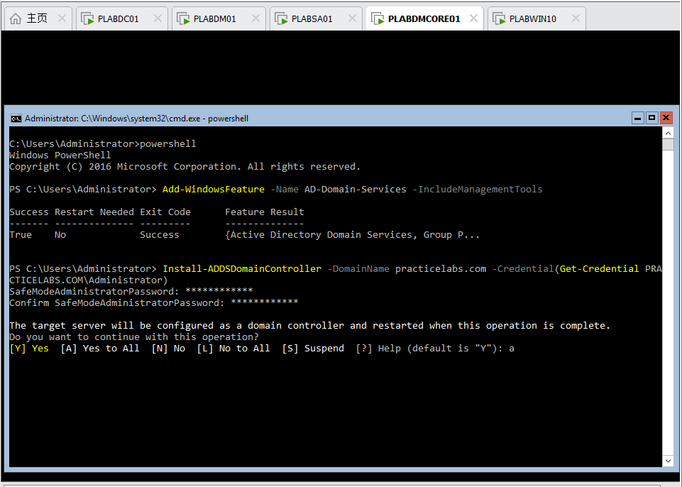

Figure 14 PLABDMCORE01: Configure ADDS SafeModeAdministratorPassword and restart, then plabdmcore01 setup is done

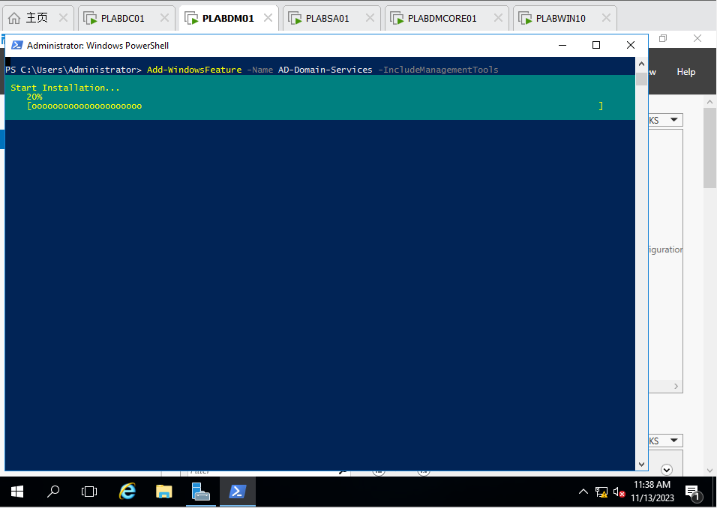

Figure 15 PLABDM01: Install ADDS including ManagementTools

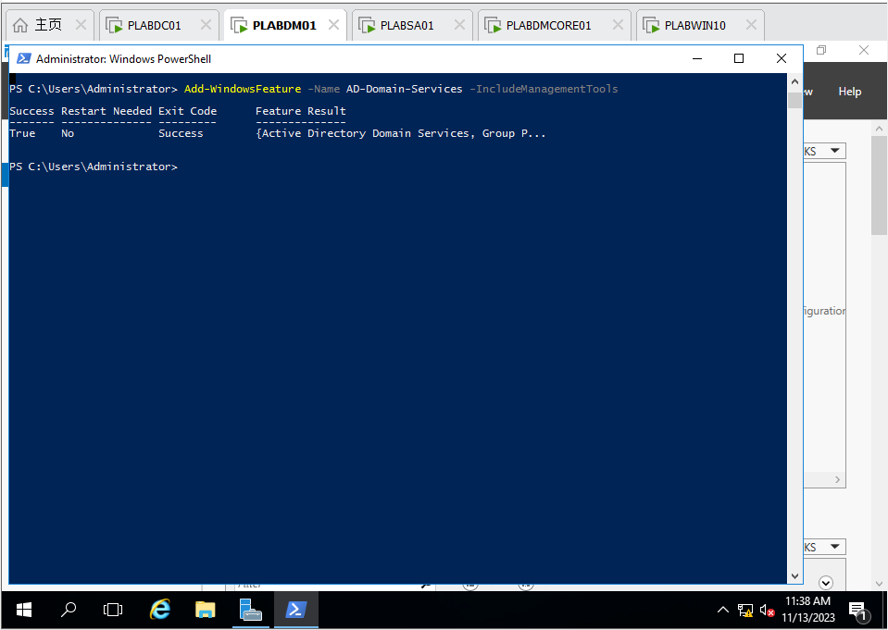

Figure 16 PLABDM01: The ADDS with ManagementTools is done

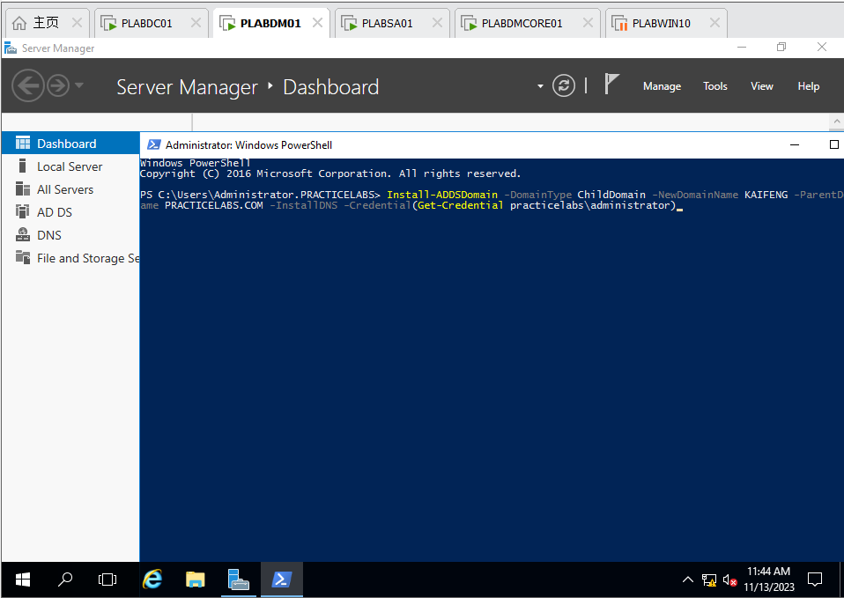

Figure 17 PLABDM01: Set plabdm01 as child domain (KAIFENG) of practicelabs.com

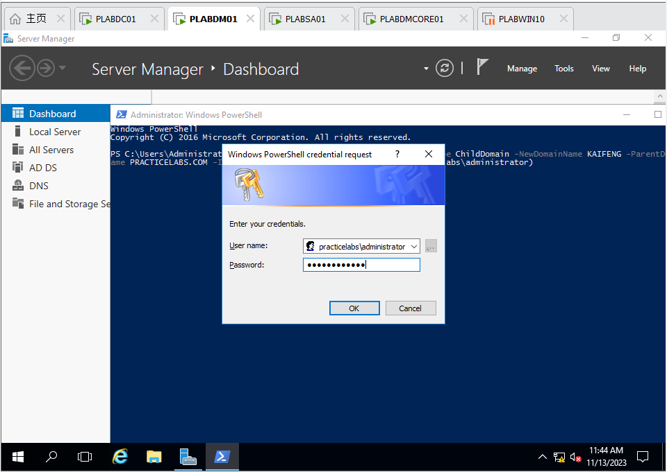

Figure 18 PLABDM01: Enter the password of *practicelabs.com*

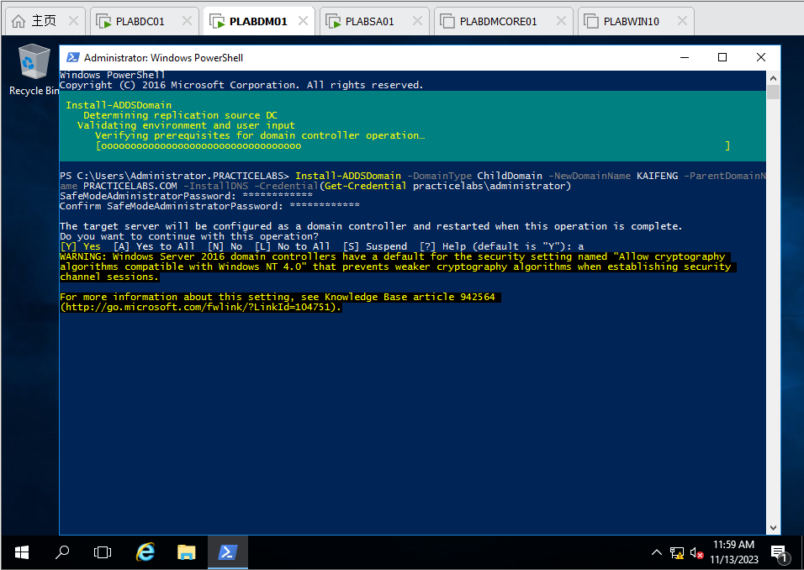

Figure 19 PLABDM01: Installing child domain (*KAIFENG*)

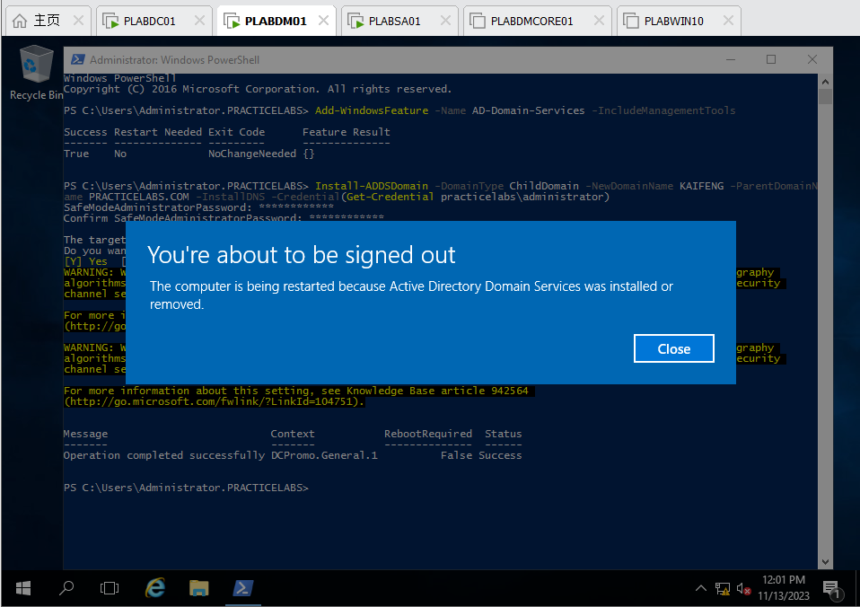

Figure 20 PLABDM01: Install successfully and reboot

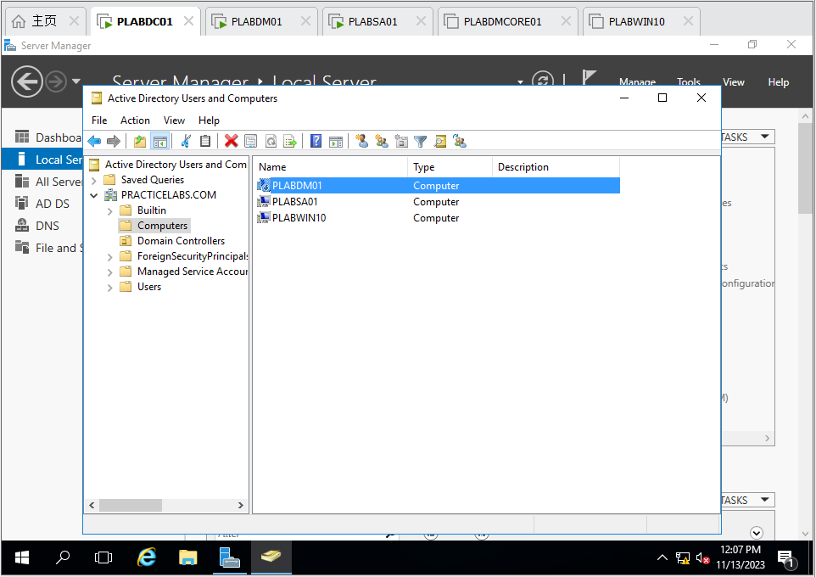

Figure 21 PLABDC01: Check the *plabdm01* and the child domain *KAIFENG* is installed successfully

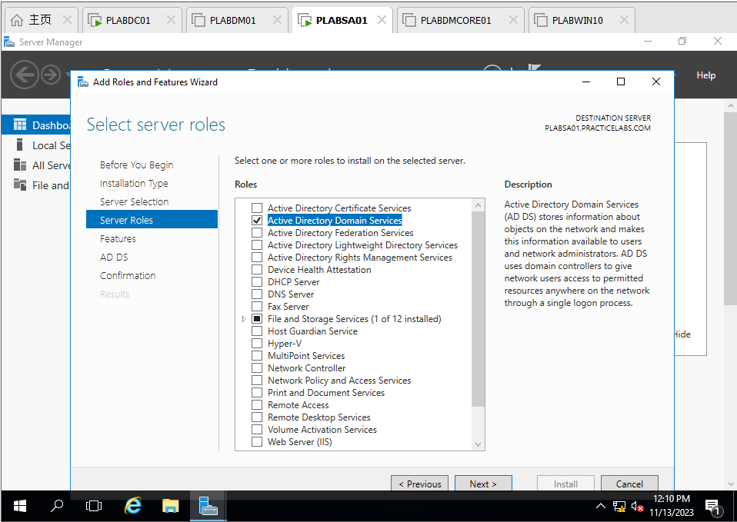

Figure 22 PLABSA01: Choose ADDS Service installation in Add Roles and Features Wizard

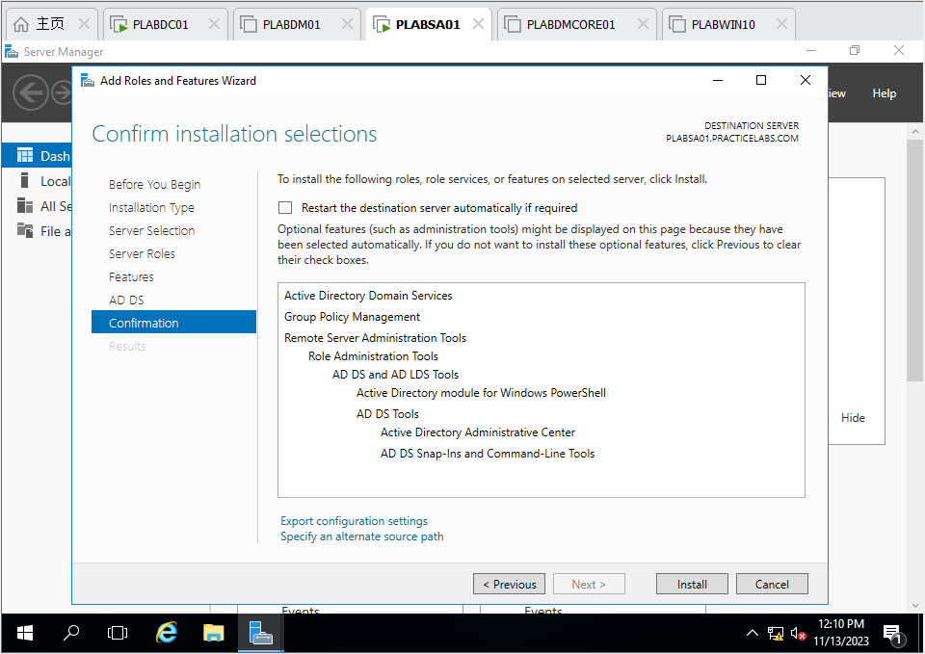

Figure 23 PLABSA01: The confirmation of ADDS Service

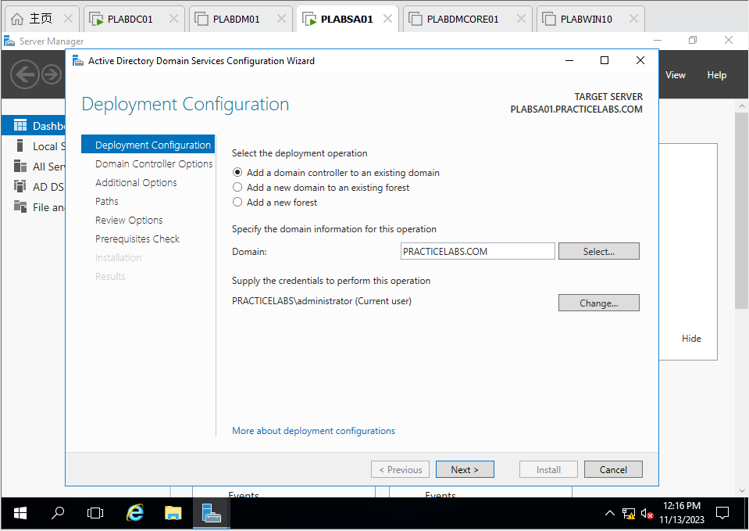

Figure 24 PLABSA01: After installing ADDS, set it as a domain controller of *practicelabs.com*

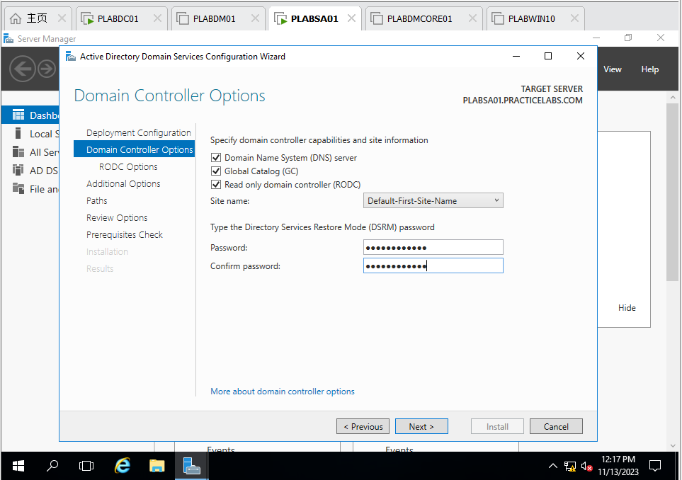

Figure 25 PLABSA01: Set is as Read only domain controller of practicelabs.com

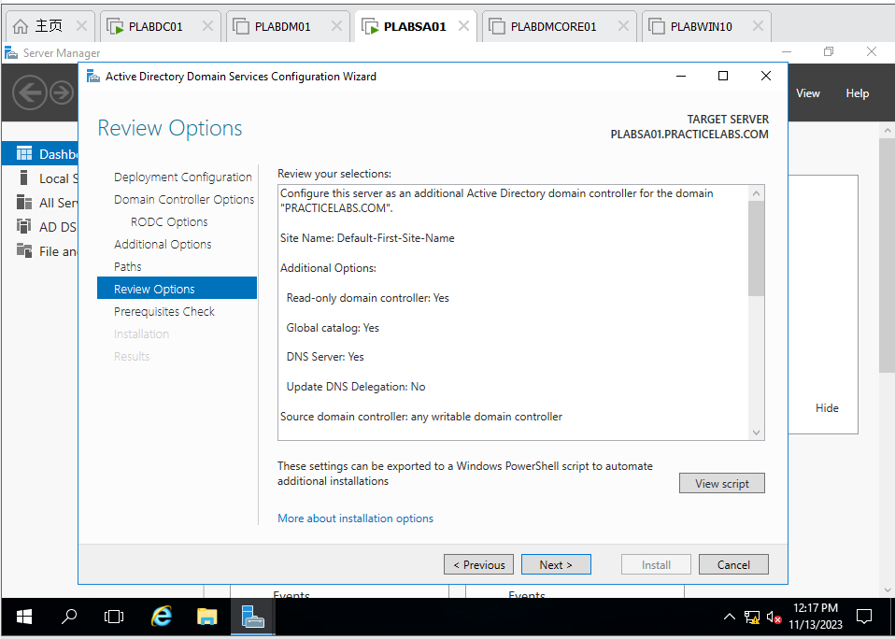

Figure 26 PLABSA01: Review options of ADDS Configuration Wizard

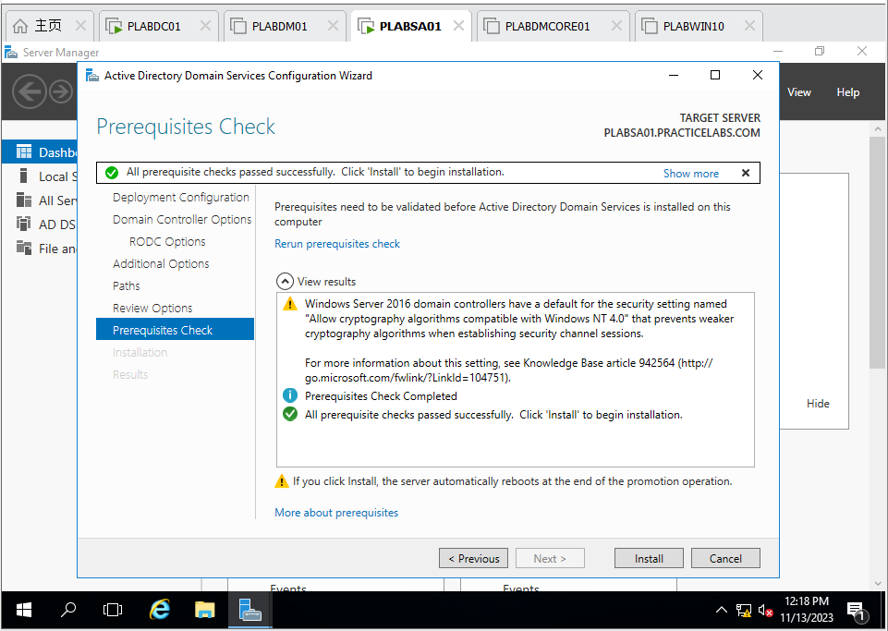

Figure 27 PLABSA01: Prerequisites check of ADDS Configuration Wizard

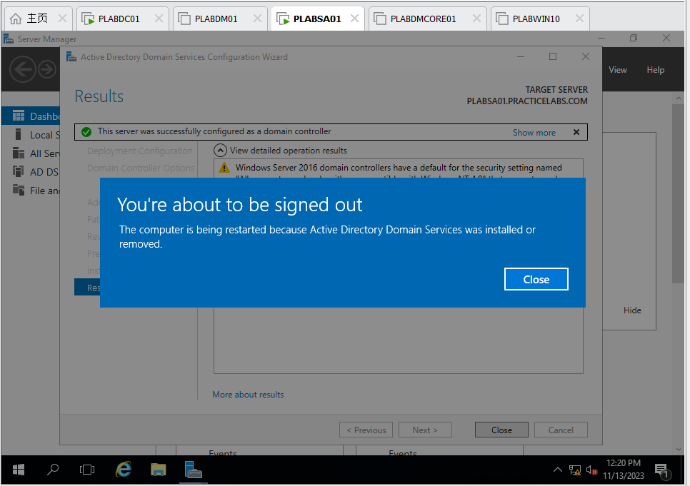

Figure 28 PLABSA01: After installation, reboot plabsa01

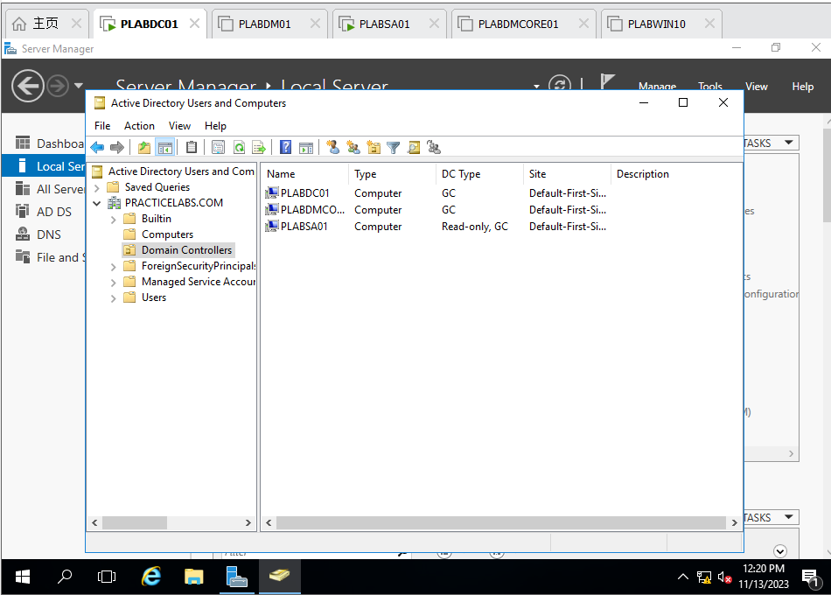

Figure 29 PLABDC01: Check the *plabsa01* installation and it is done

Use commands **dates;ipconfig /all** to verify the new configurations, and take screenshots for each server/computer.

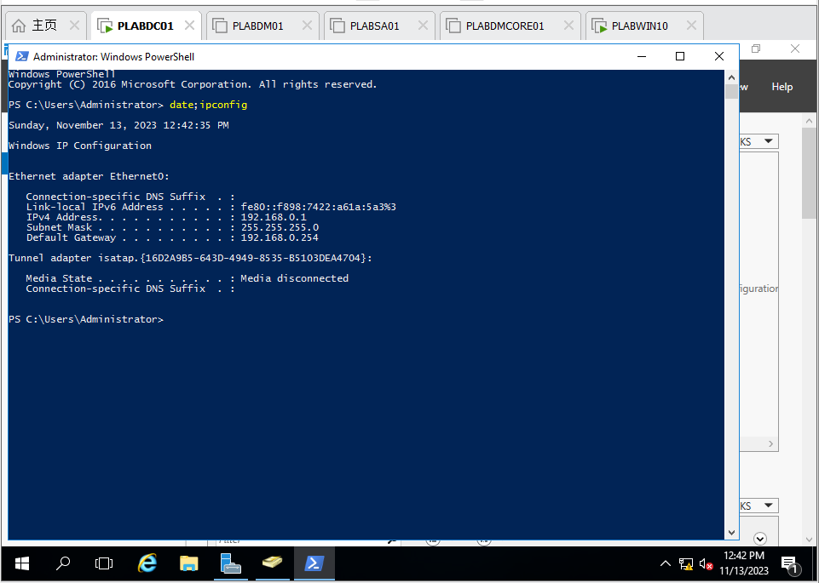

Figure 30 PLABDC01: command date;ipconfig

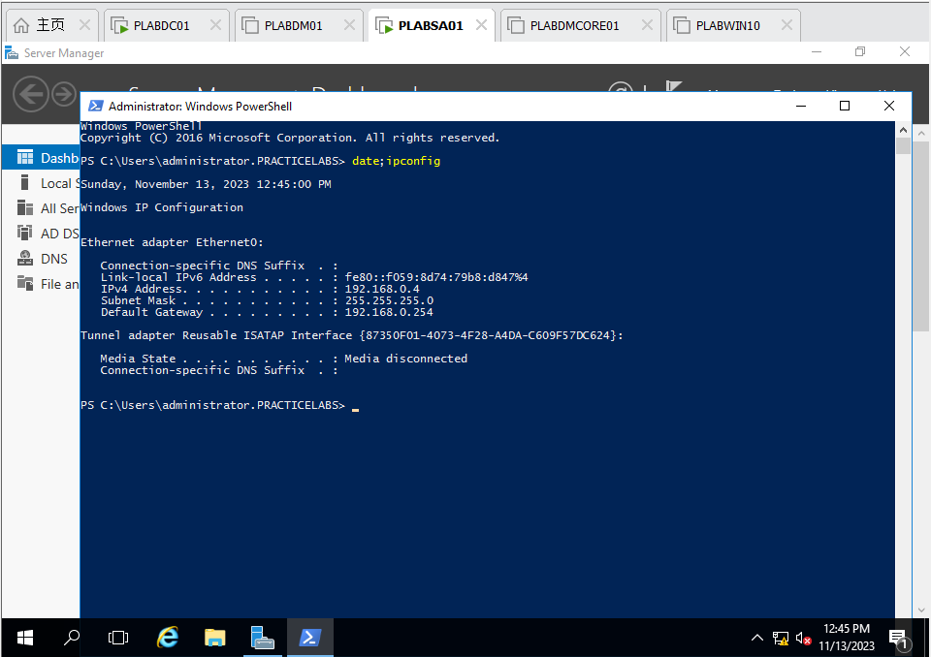

Figure 31 PLABSA01: command date;ipconfig

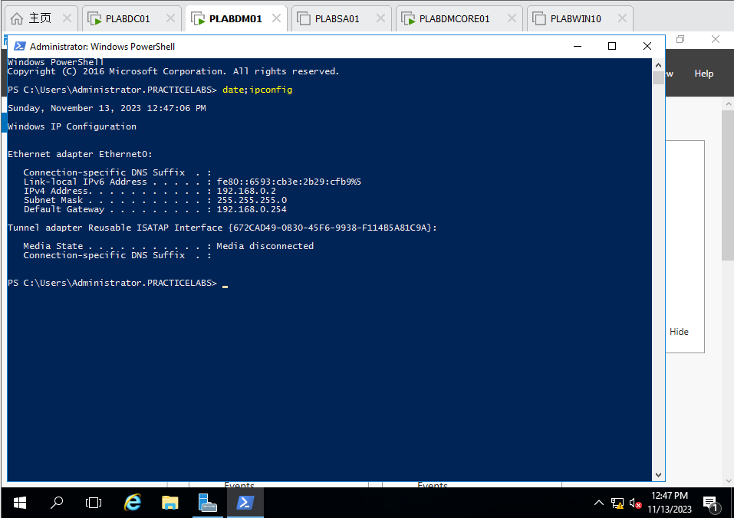

Figure 32 PLABDM01: command date;ipconfig

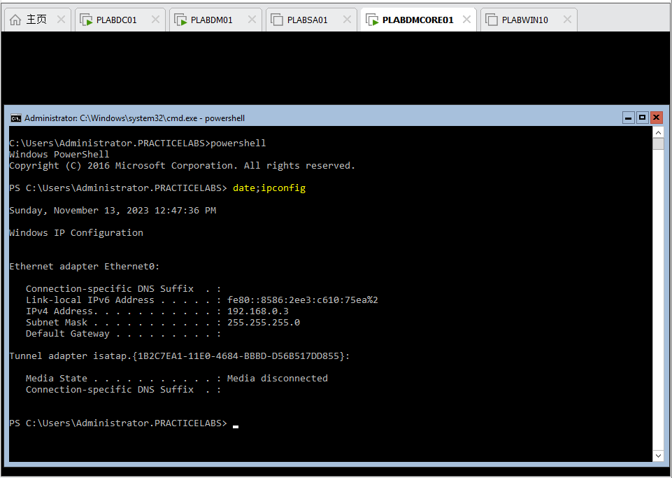

Figure 33 PLABDMCORE01: command date;ipconfig

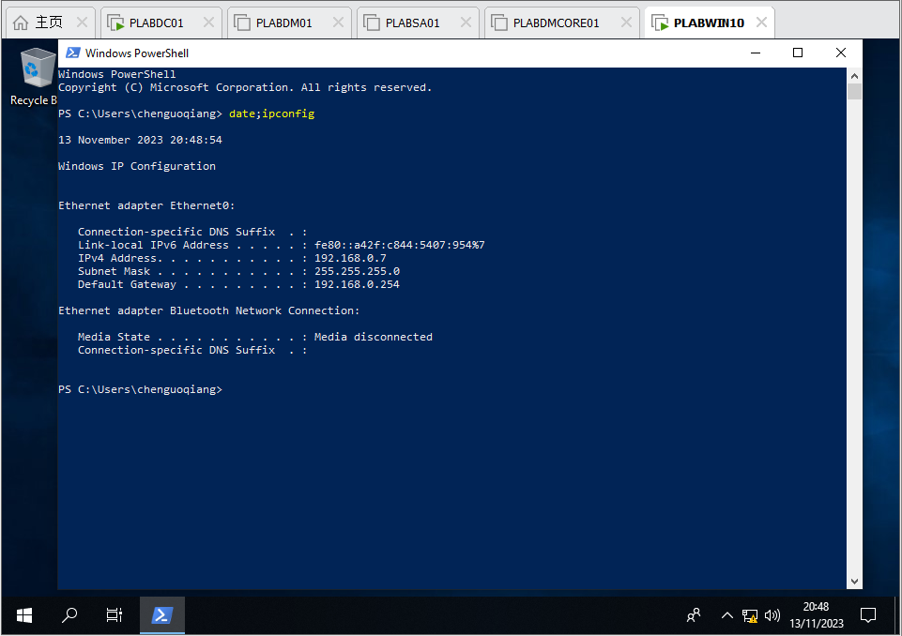

Figure 34 PLABWIN10: command date;ipconfi

**Task 3 – Active Directory Management** (15%)

• **A – User Account and Group Management** (5%)

o Create an Organization Unit called **NIT3122HENU**

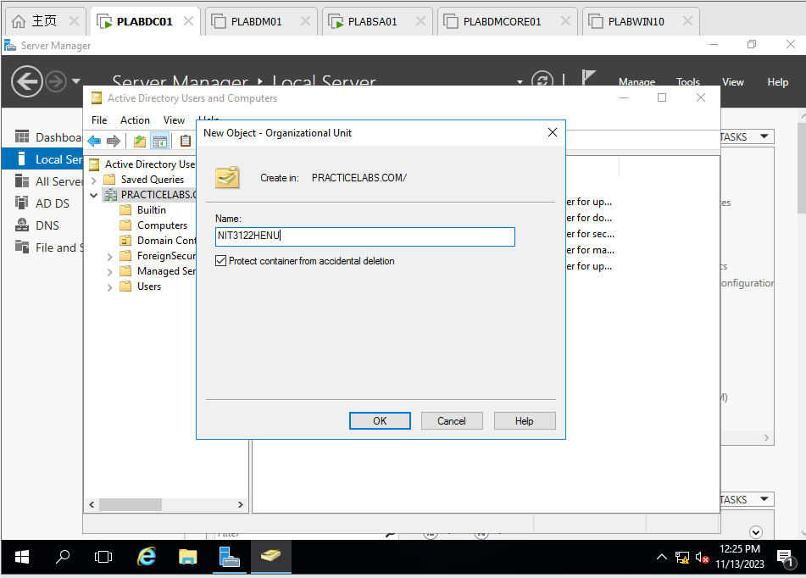

Figure 35 PLABDC01: Create NIT3122HENU OU in practicelabs.com

Inside **NIT3122HENU** OU, create a global security group called **NIT3122CGO**.

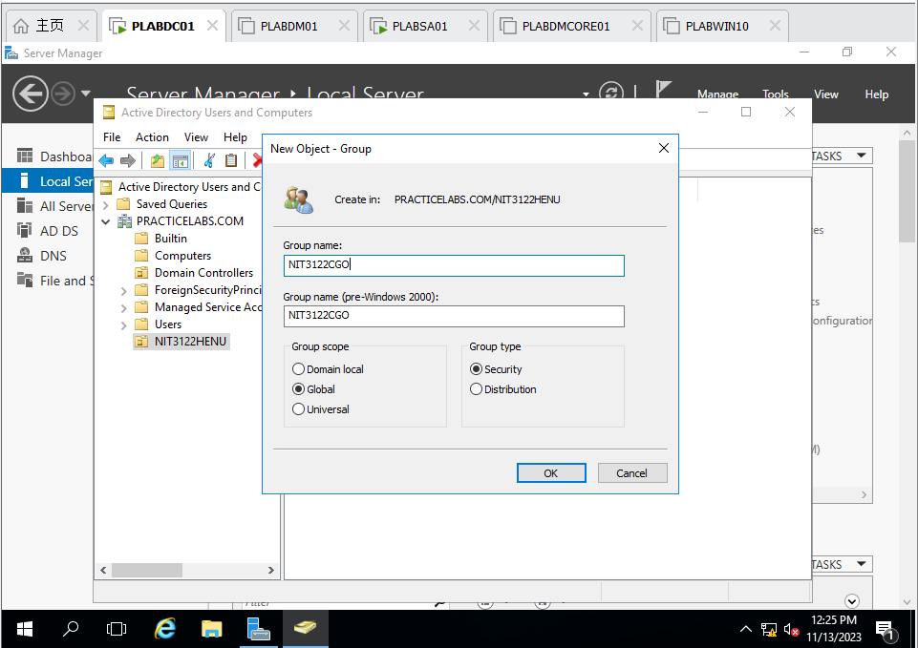

Figure 36 PLABDC01: Create NIT3122CGO IN NIT3122HENU

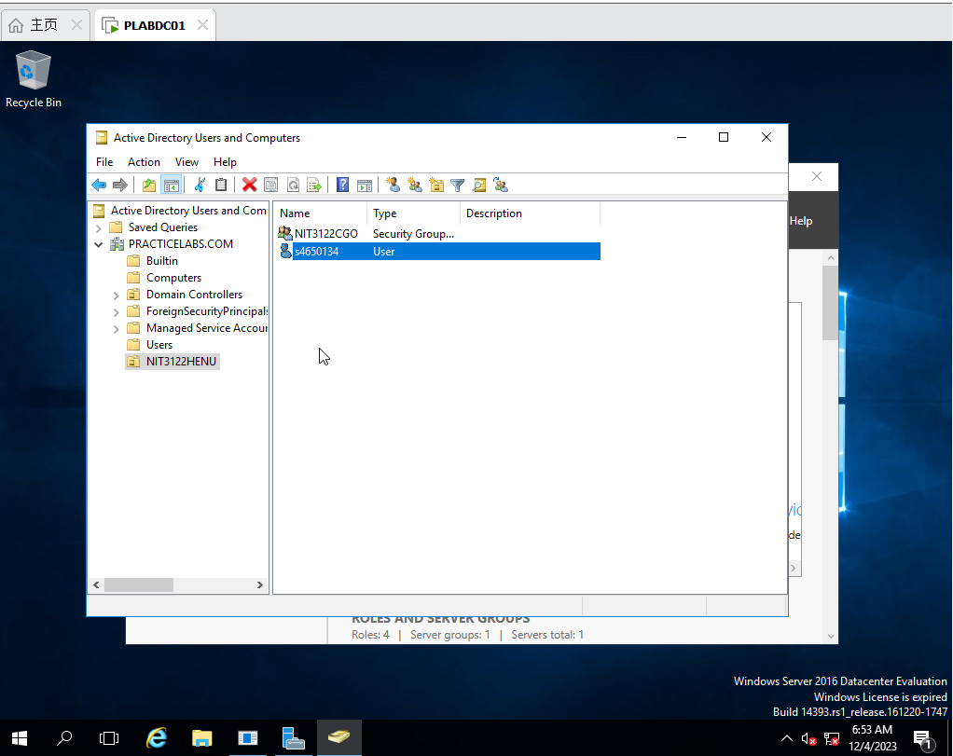

Figure 37 PLABDC01: Check NIT3122CGO successfully

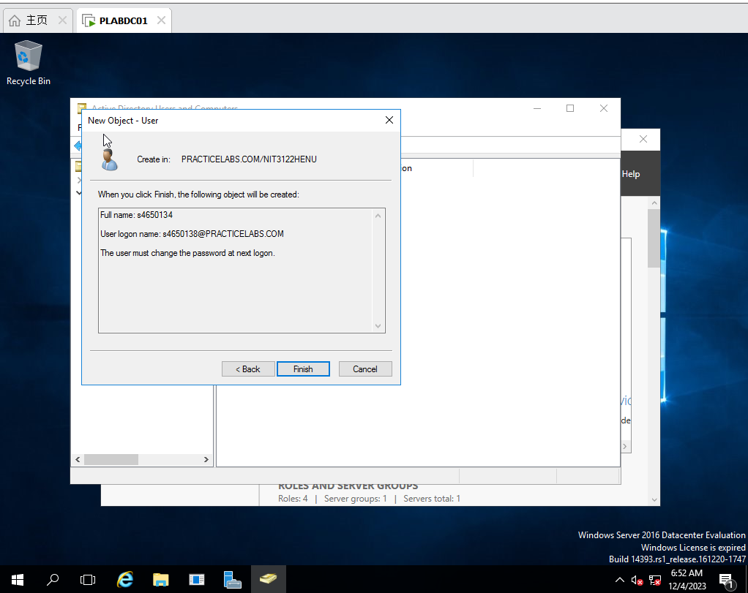

Figure 38 PLABDC01: Create new user s4650134 and enable User must change password at next logon

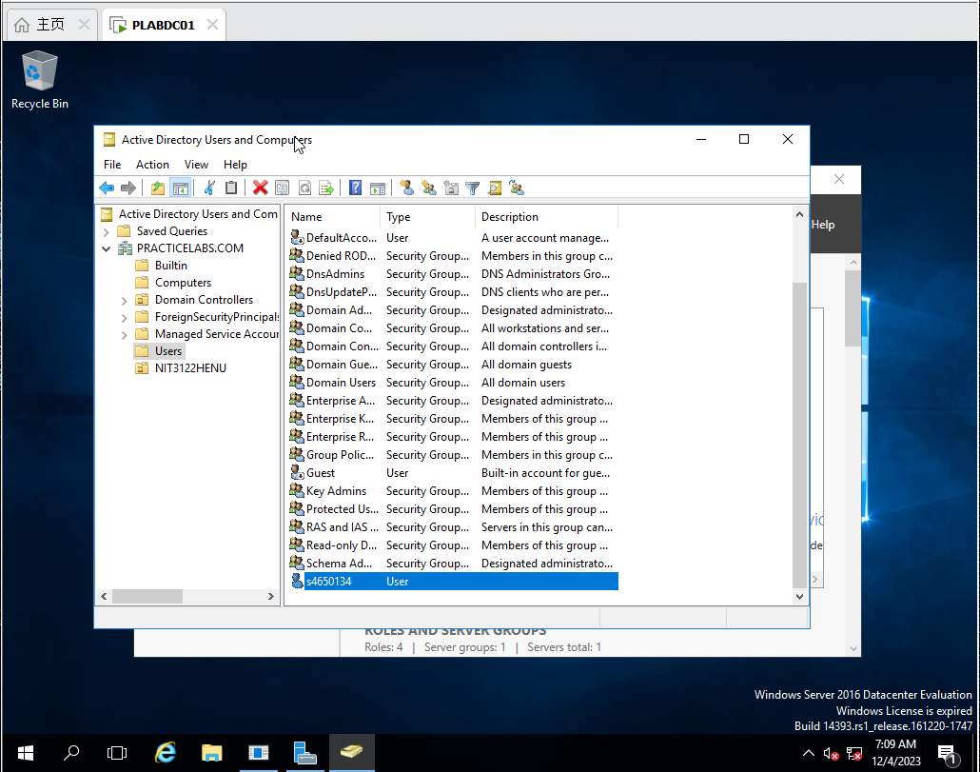

Figure 39 PLABDC01: create new user s4650134 successfully

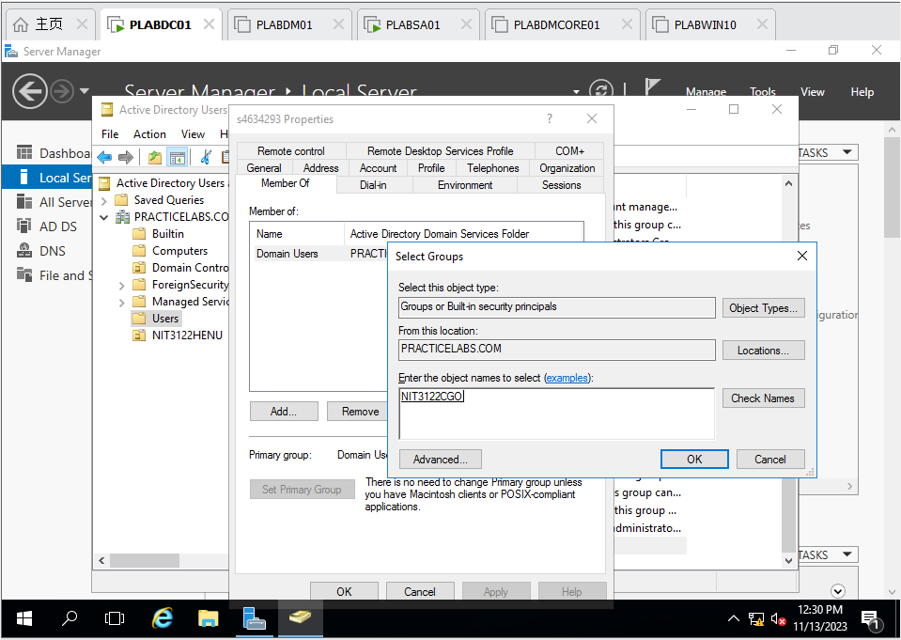

Figure 40 PLABDC01 : make s4650134 belongs to NIT3122CGO

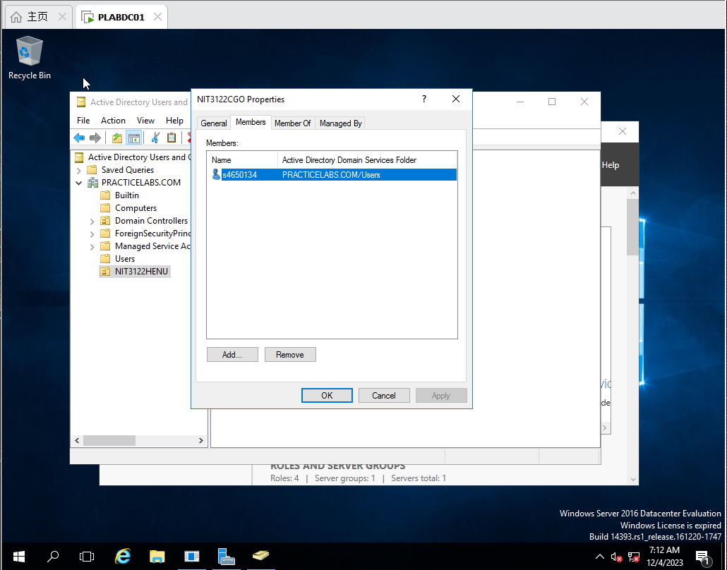

Figure 41 PLABDC01: join successfully

o Create 2nd new user using your **Lab Tutor’s** name as Domain **Administrator** who is a member of **NIT3122CGO** and whose password never expiries.

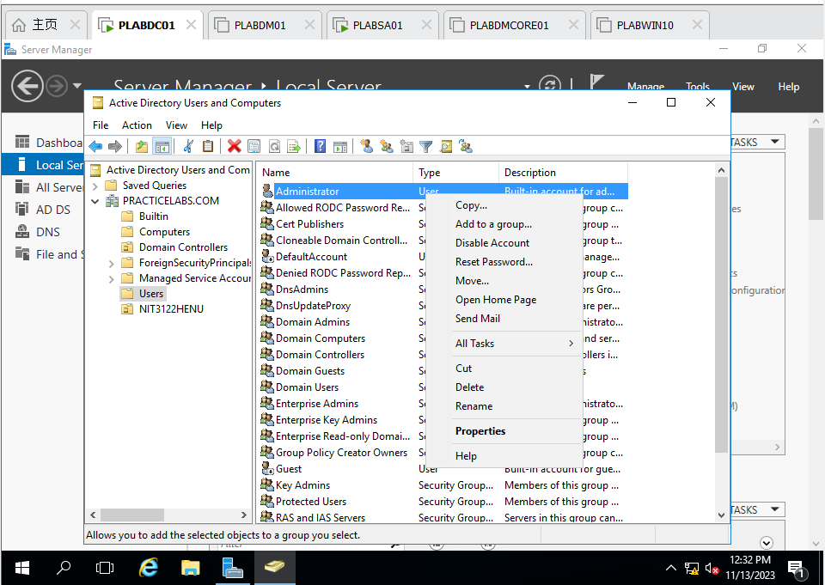

Figure 42 PLABDC01: Copy Administrator as new user Chen Guoqiang

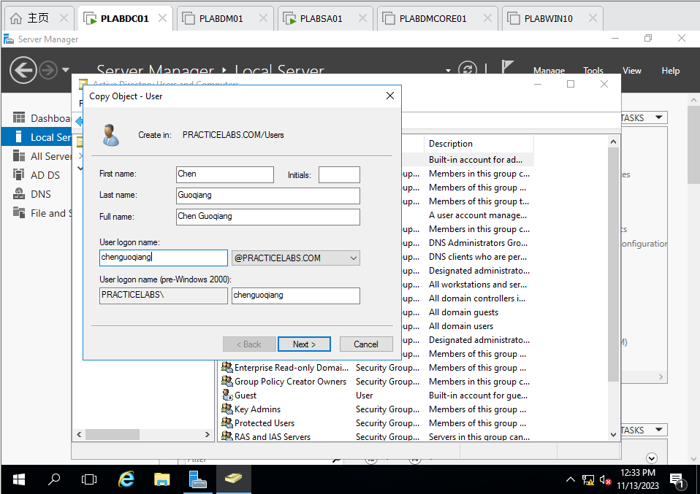

Figure 43 PLABDC01: setup information of user Chen Guoqiang

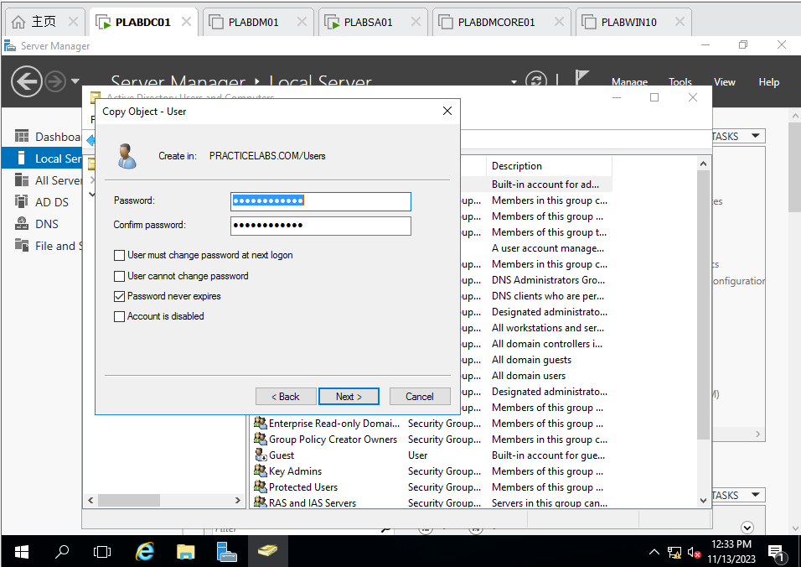

Figure 44 PLABDC01: Setup password of user Chen Guoqiang (CHECK Password never expires)

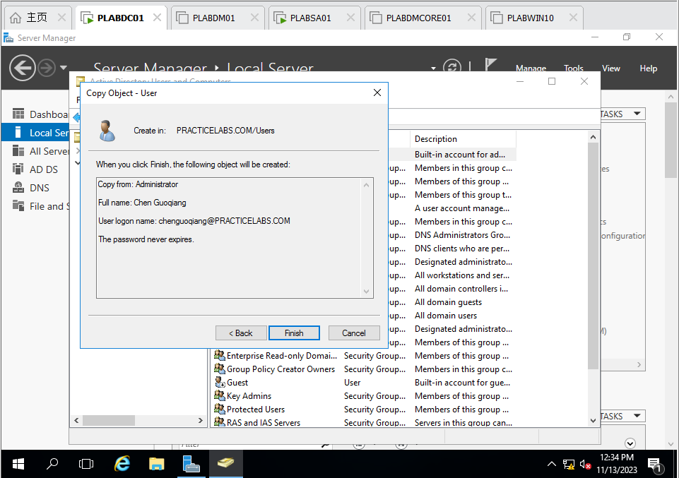

Figure 45 PLABDC01: Overview of User Chen Guoqiang

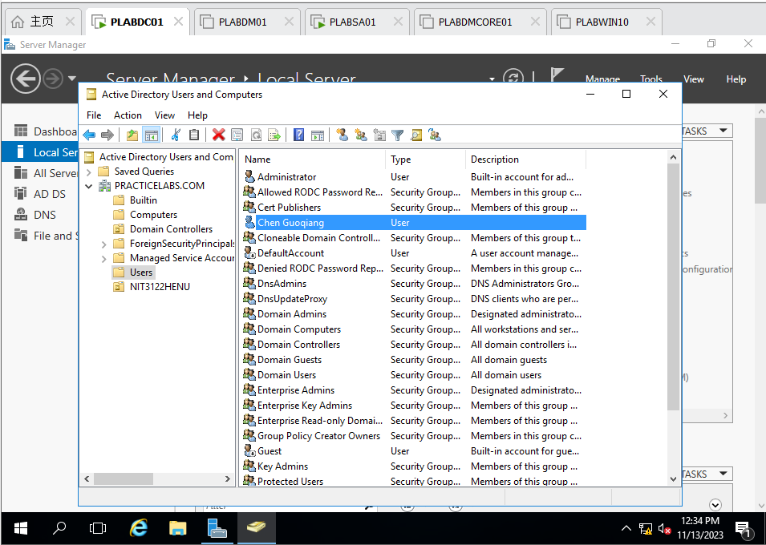

Figure 46 PLABDC01: Check User Chen Guoqiang created successfully

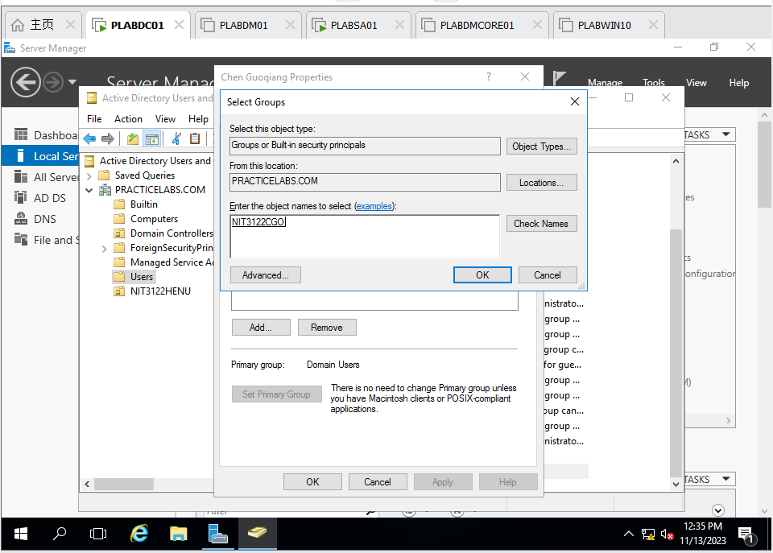

Figure 47 PLABDC01: Add User Chen Guoqiang to NIT3122CGO

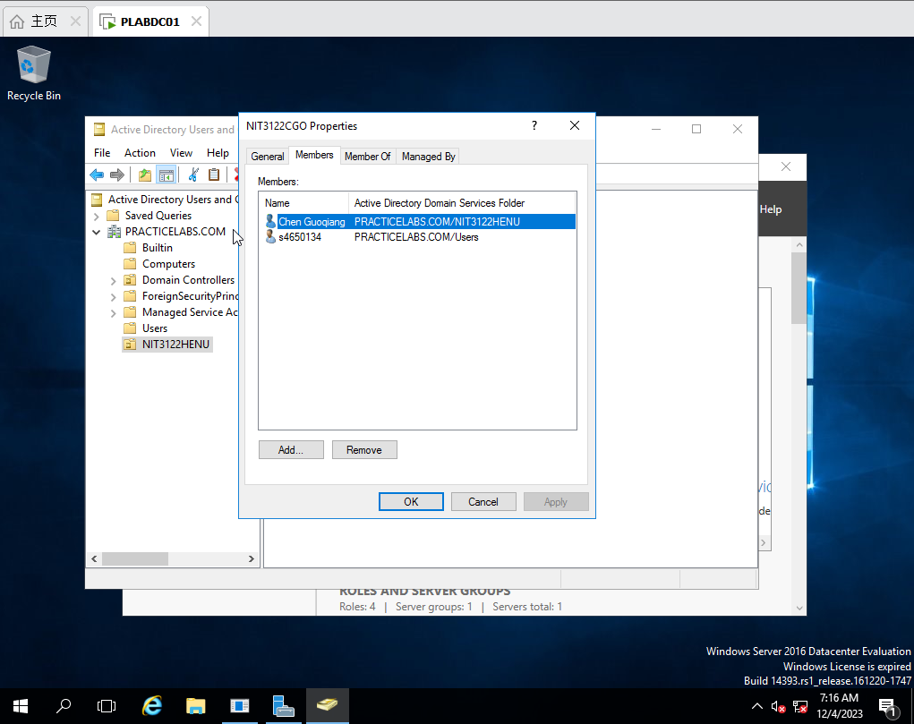

Figure 48 PLABDC01: Check Add successfully

o Log on the testing computer to verify the above two user settings are working.

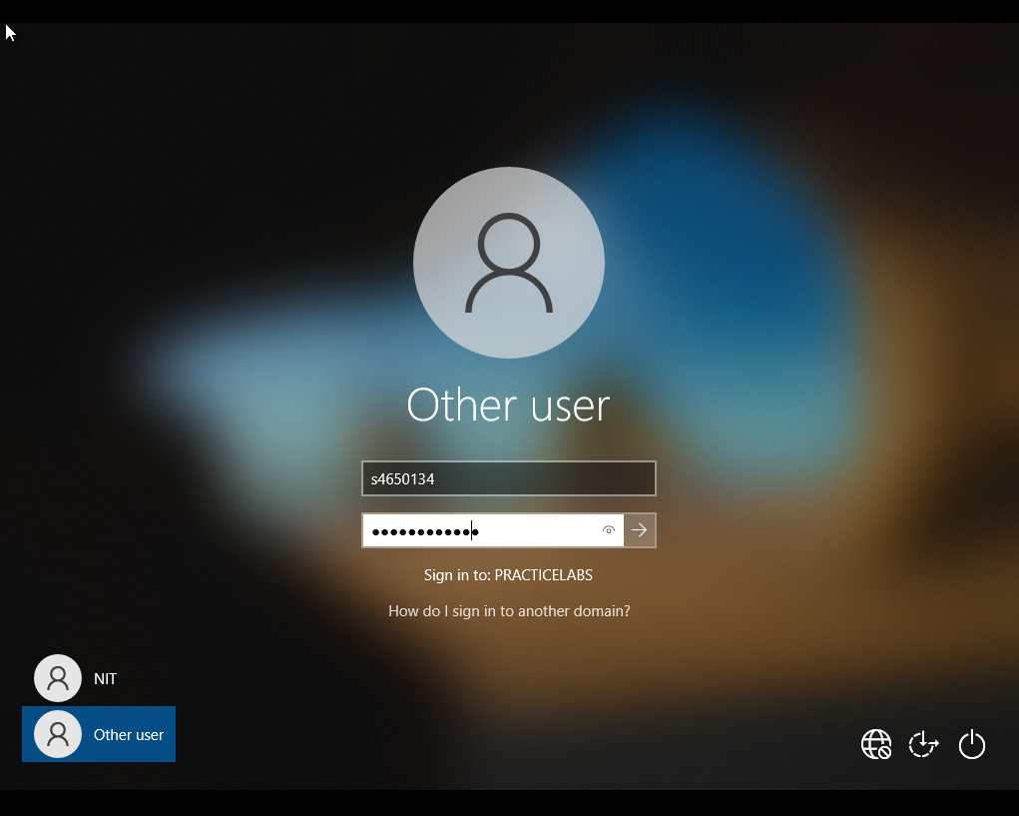

Figure 49 PLABWIN10: Log as s4650134

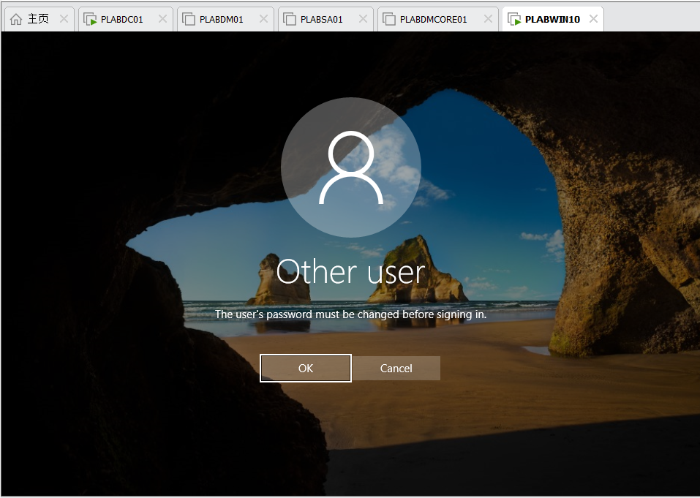

Figure 50 PLABWIN10: Notice that the password must be changed



Figure 51 PLABWIN10: enter new password

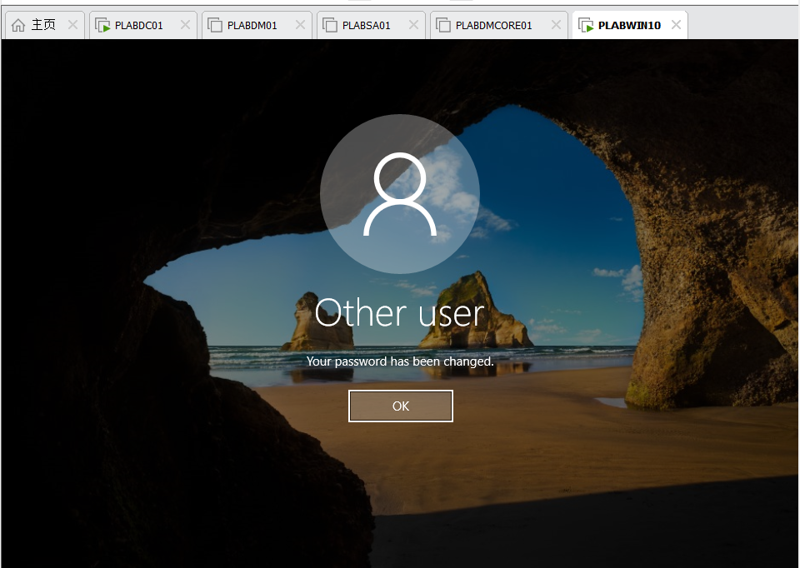

Figure 52 PLABWIN10: Change password successfully

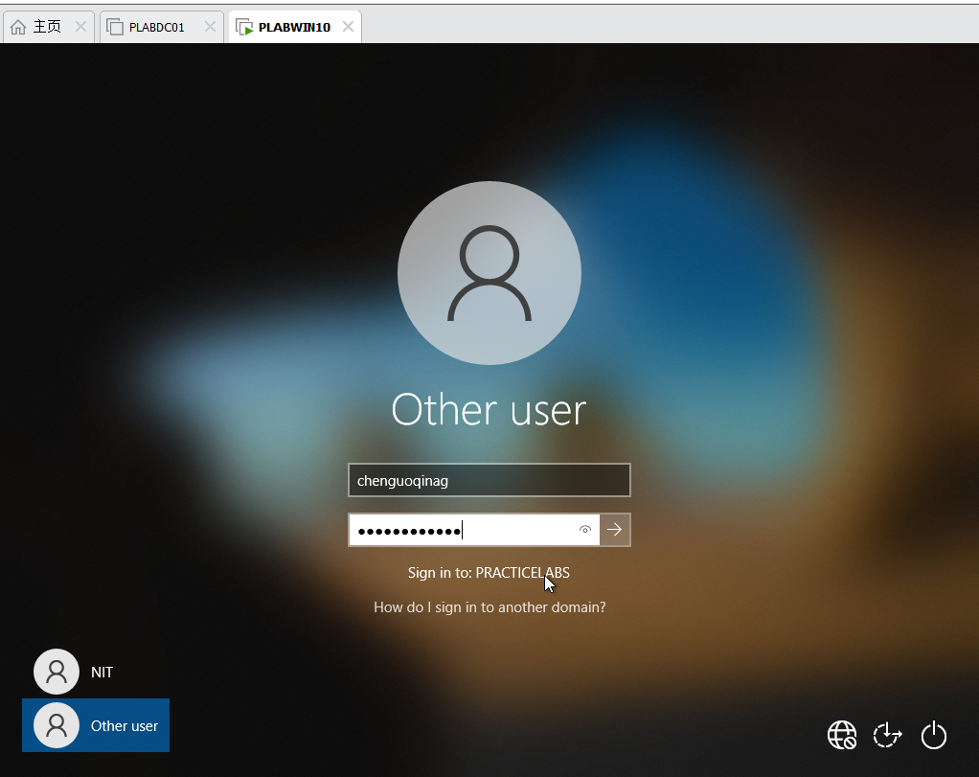

Figure 53 PLABWIN10: Log as Chen Guoqiang

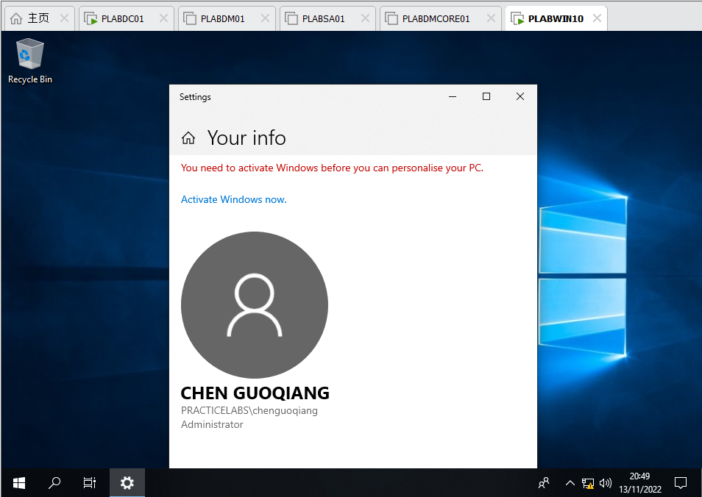

Figure 54 PLABWIN10: Check user information

o Take screenshots of the above account creation, **NIT3122HENU** folder and **NIT3122CGO** Member List.

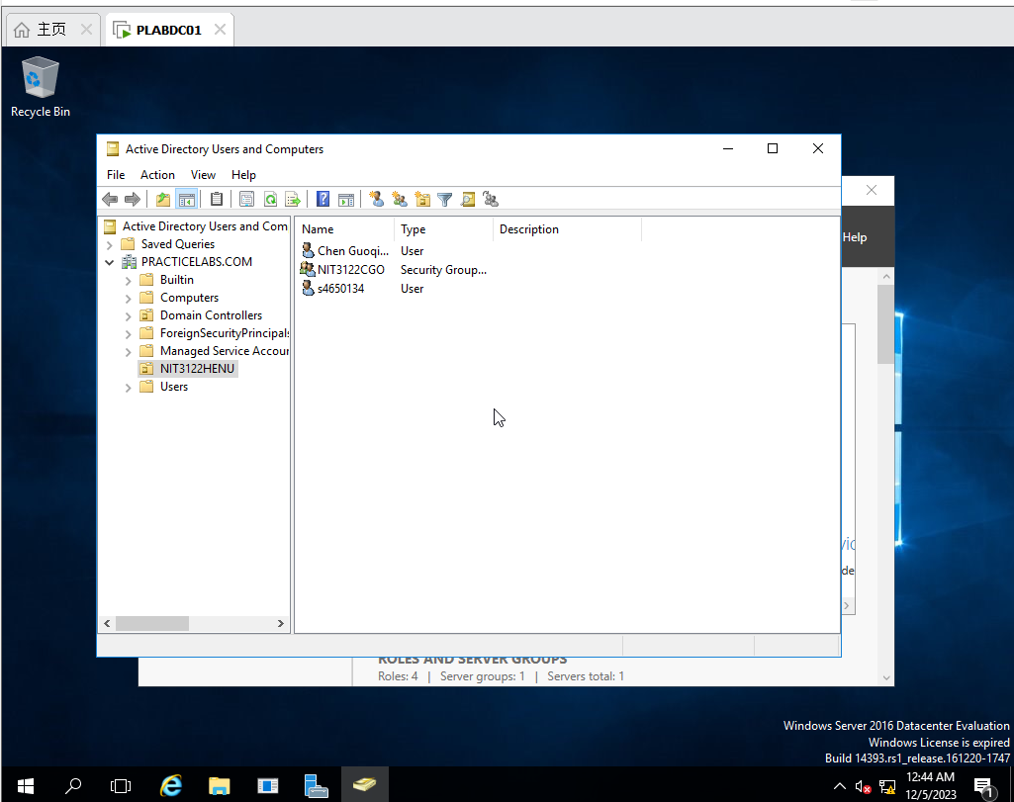

Figure 55 PLABDC01: Check items in NIT3122HENU



Figure 56 PLABDC01: Check members in NIT3122CGO

• **B – Application Management** (5%)

o Create a new GPO named “**Desktop restrictions**” which **Prohibit access to Control Panel and PC settings** for **NIT3122HENU** OU

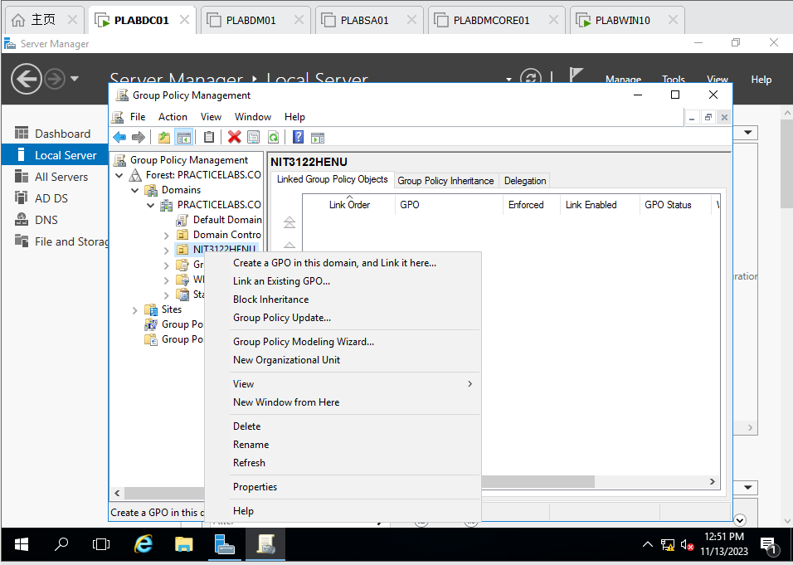

Figure 57 PLABDC01: Create a GPO for NIT3122HENU

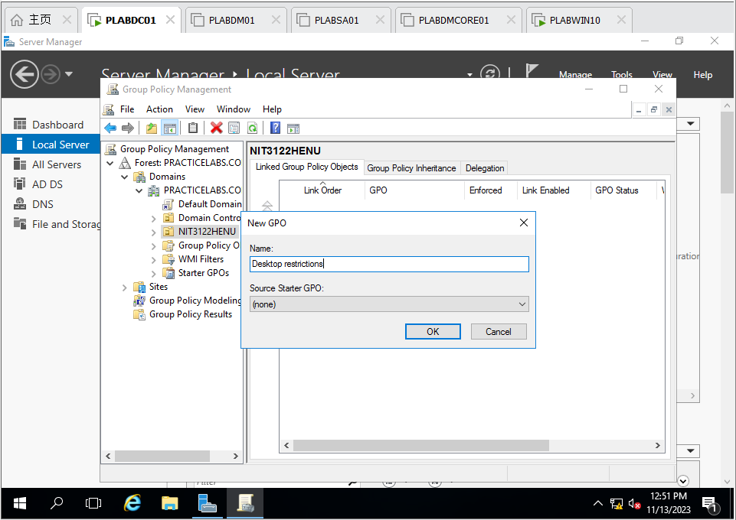

Figure 58 PLABDC01 : Name the GPO as Desktop restriction

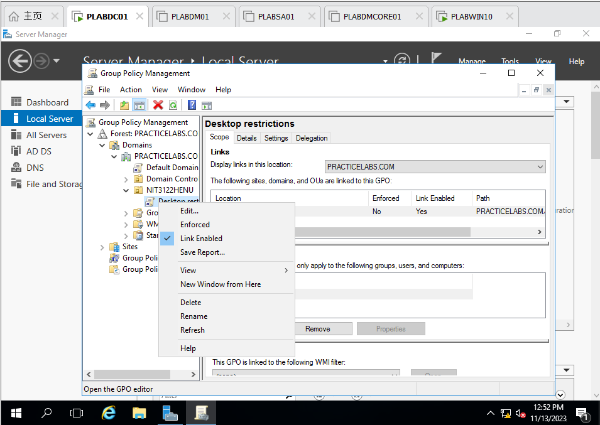

Figure 59 PLABDC01 : Edit the new policy

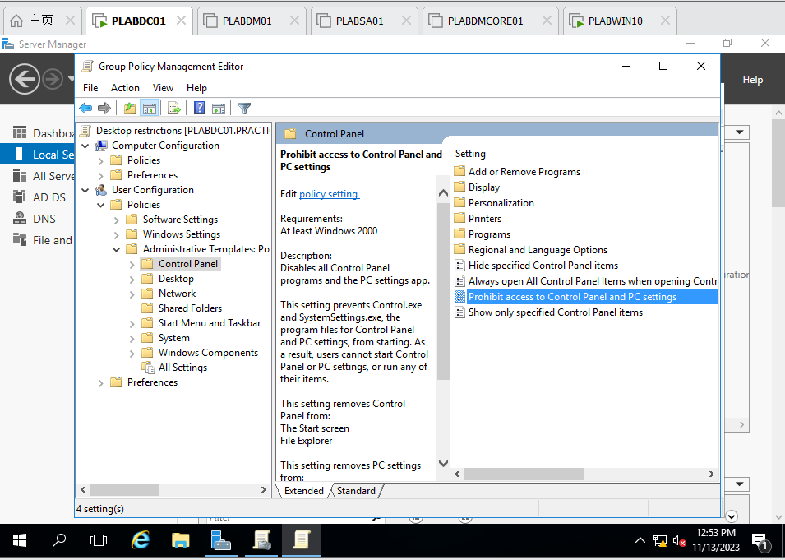

Figure 60 PLABDC01 : Select Prohibit access to Control Panel and PC settings and edit

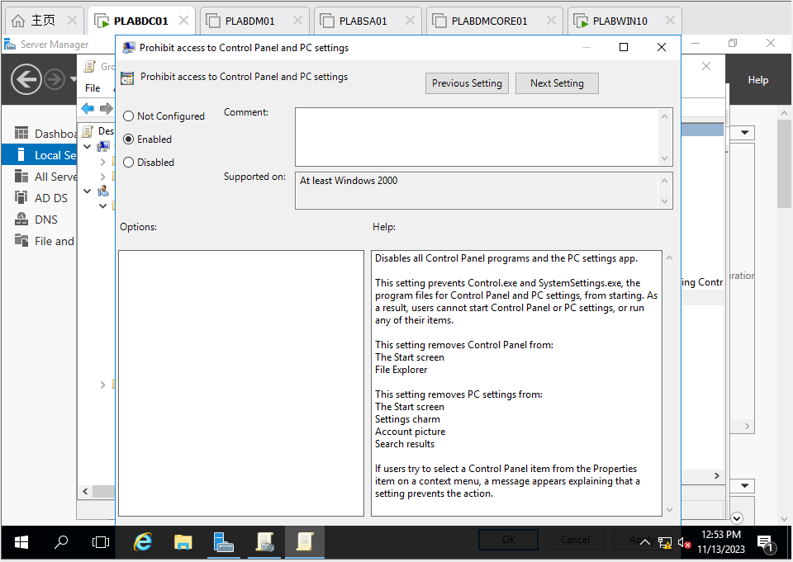

Figure 61 PLABDC01 : Choose Enable button

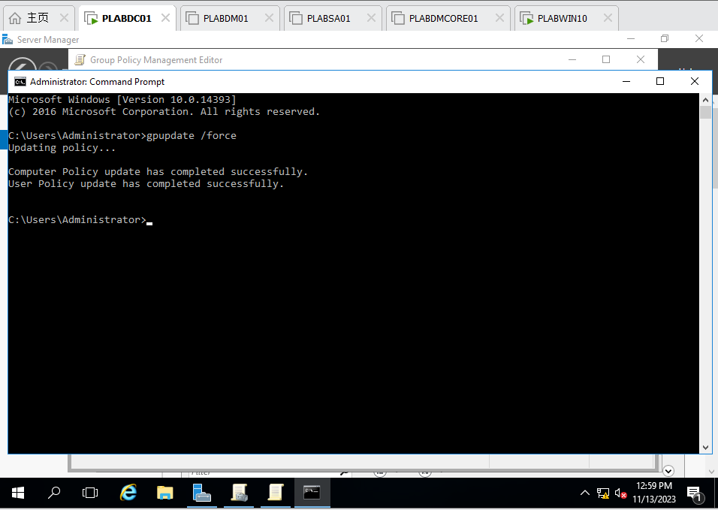

Figure 62 PLABDC01 : Update the policy and apply

o Use **YourID** to log on the testing computer to verify the setting is working.

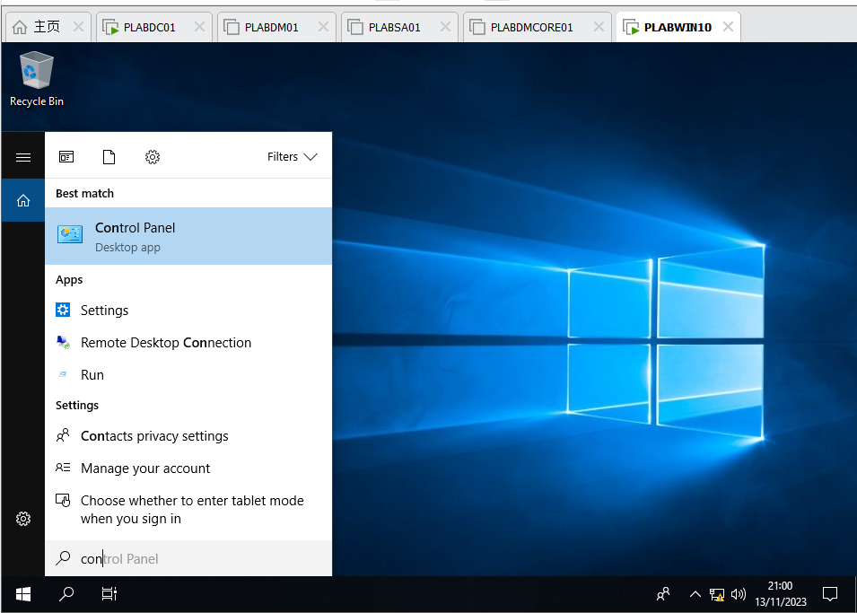

Figure 63 PLABWIN10 : Find Control Panel

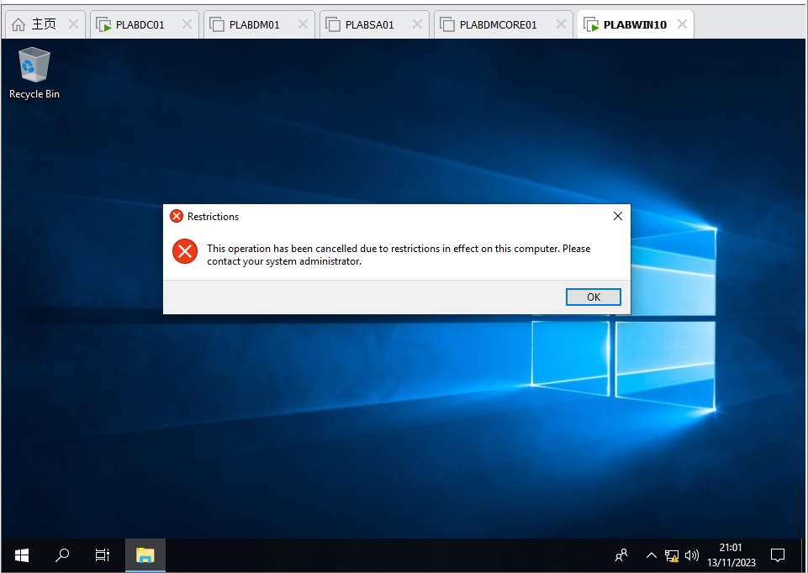

Figure 64 PLABWIN10 : Try to launch Control Panel and find it is not work because the Group Policy prohibit

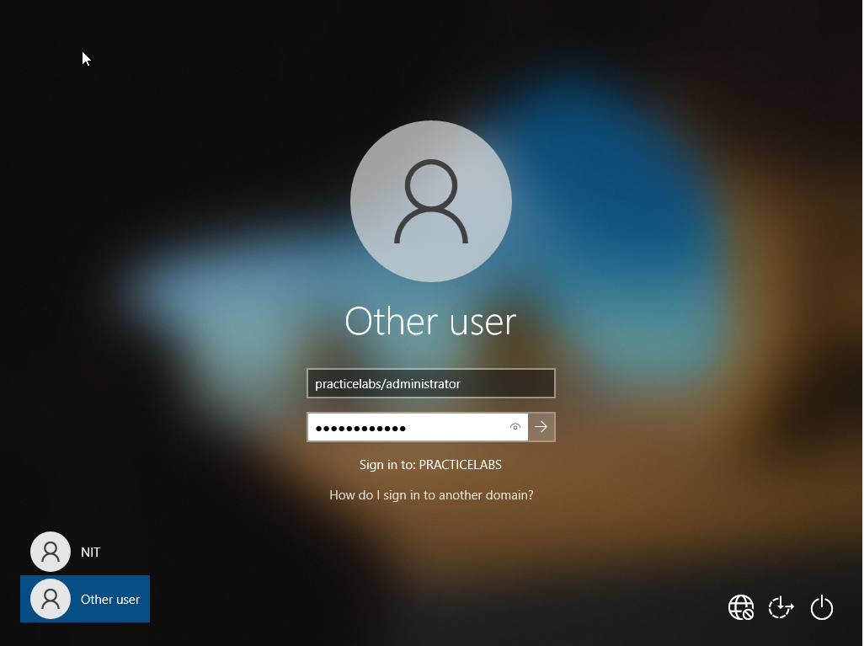

Figure 65 PLABWIN10: Enter password of administrator

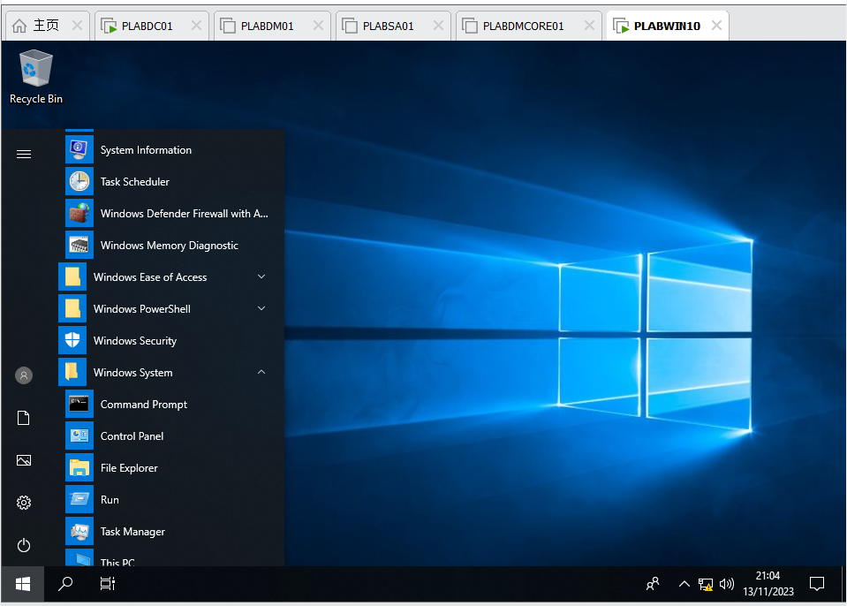

Figure 66 PLABWIN10 : Find Control Panel

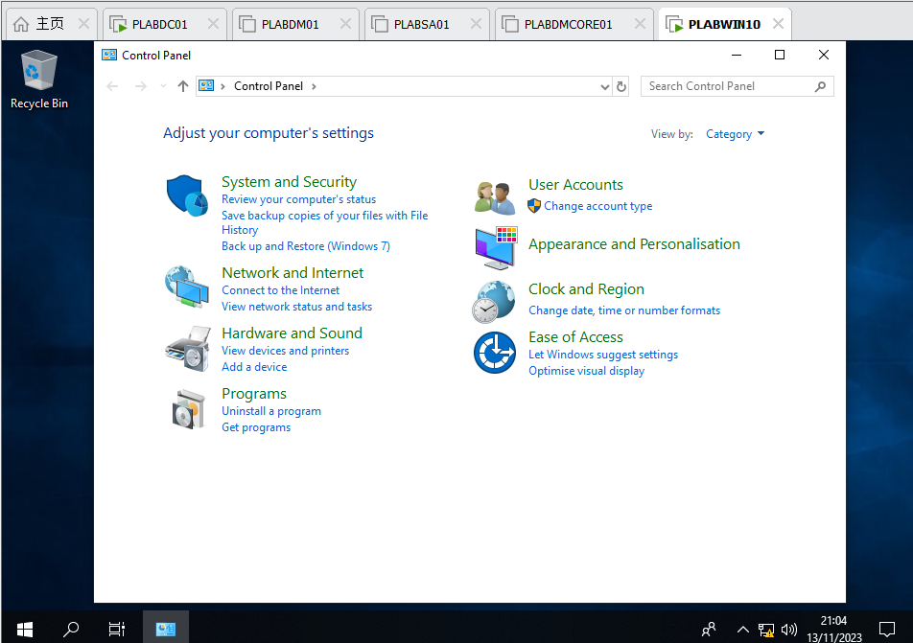

Figure 67 PLABWIN10 : launch Control Panel successfully

o Take screenshots of the above procedures and explain the results.

• **C –** **Software Management** (5%)

o Create another new GPO named “**Software restrictions**” which block users in **NIT3122CGO** from opening **Notepad.exe** on any computer in the domain **PracticeLabs.com**.

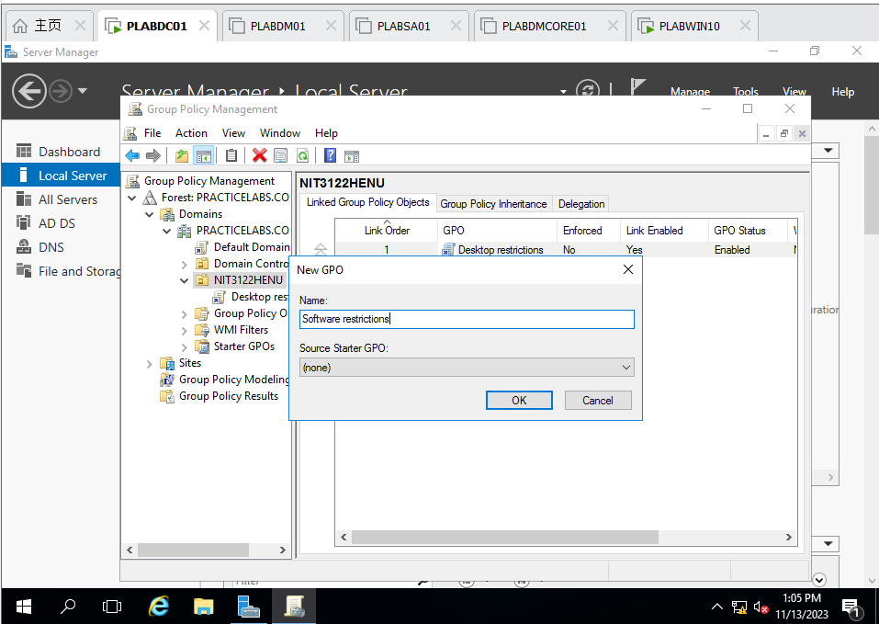

Figure 68 PLABDC01 : Back to Plabdc01 and create new GPO named Software restrictions

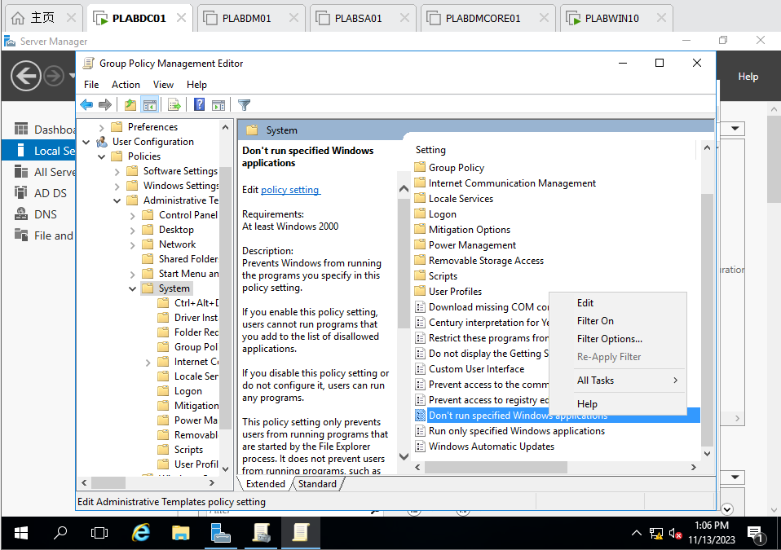

Figure 69 PLABDC01 : Find Don’t run specified Windows applications and edit

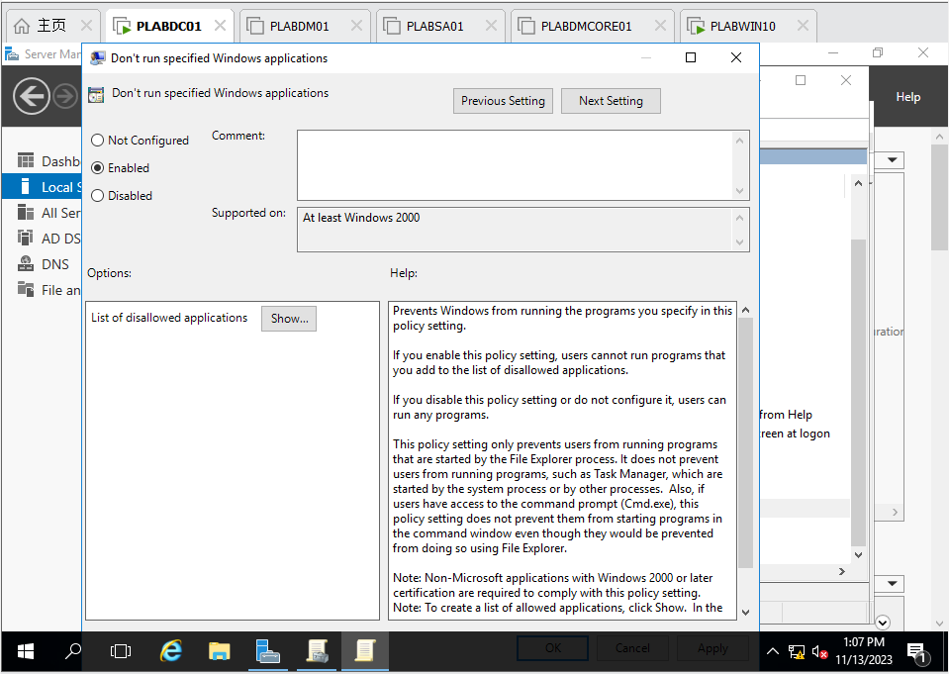

Figure 70 PLABDC01 : Choose Enable and click show

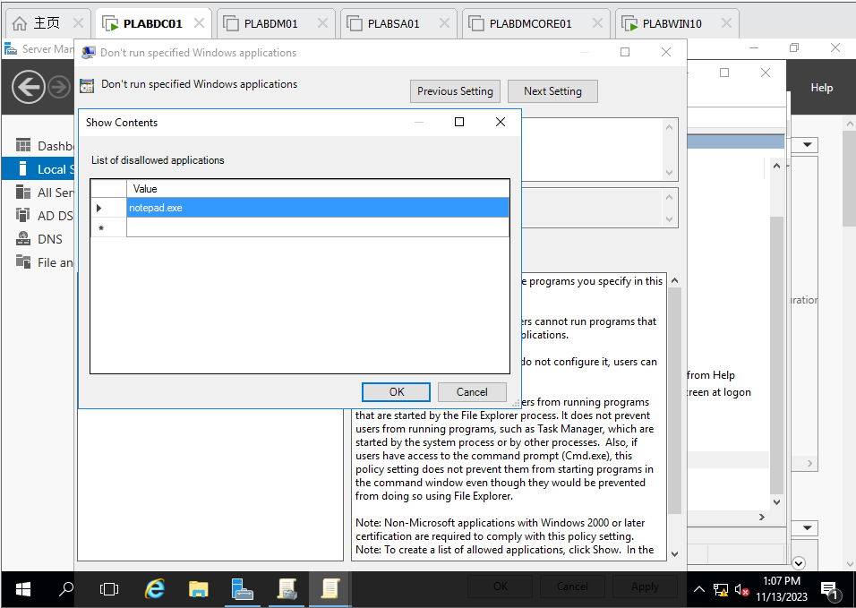

Figure 71 PLABDC01 : Enter notepad.exe, prohibit this application

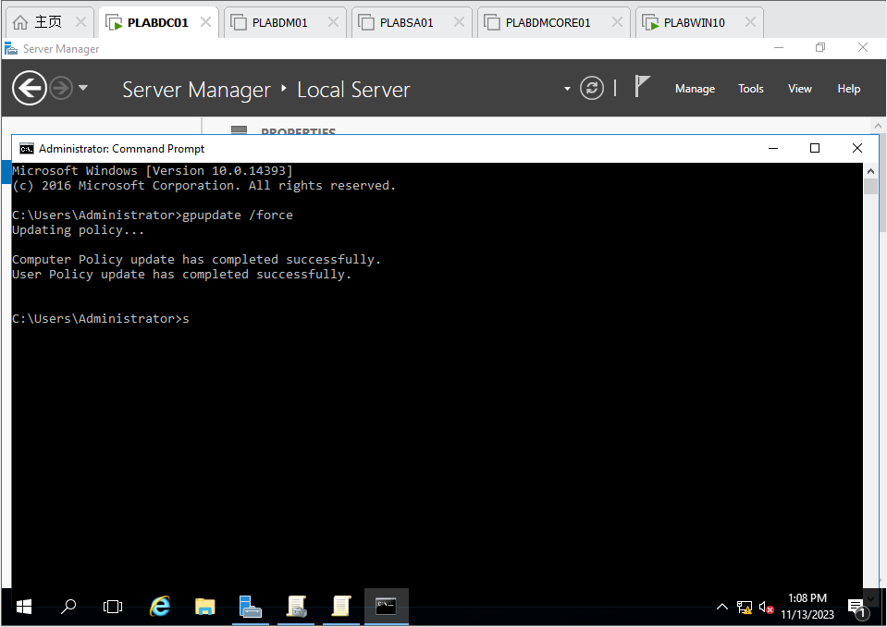

Figure 72 PLABDC01 : Update the policy successfully

o Use **YourID** to log on the testing computer (**PLABWIN10**) to verify if Notepad.exe can be opened.



Figure 73 PLABWIN10 : Login as s4650134

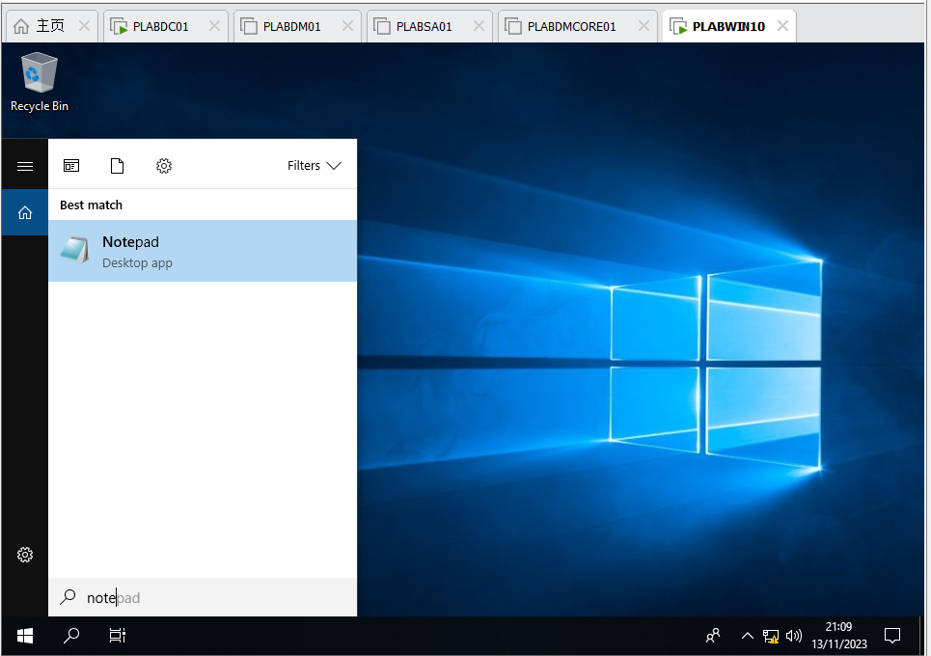

Figure 74 PLABWIN10 : Find Notepad application and try to launch, find that it is prohibited because the policy worked

o Use **Lisa.Scott,** an existing user to log on the testing computer (**PLABWIN10**) to verify the setting.

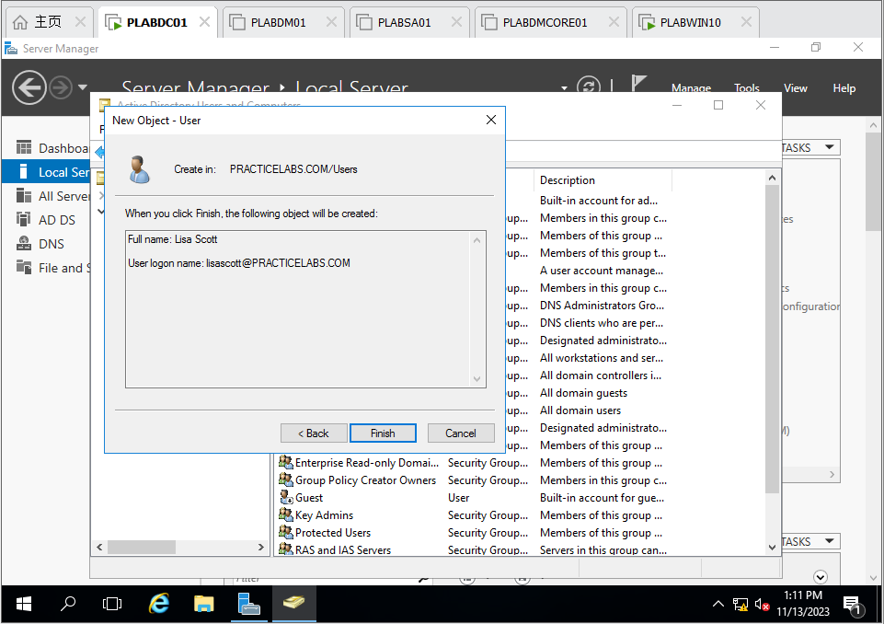

Figure 75 PLABDC01 : Create new user lisascott

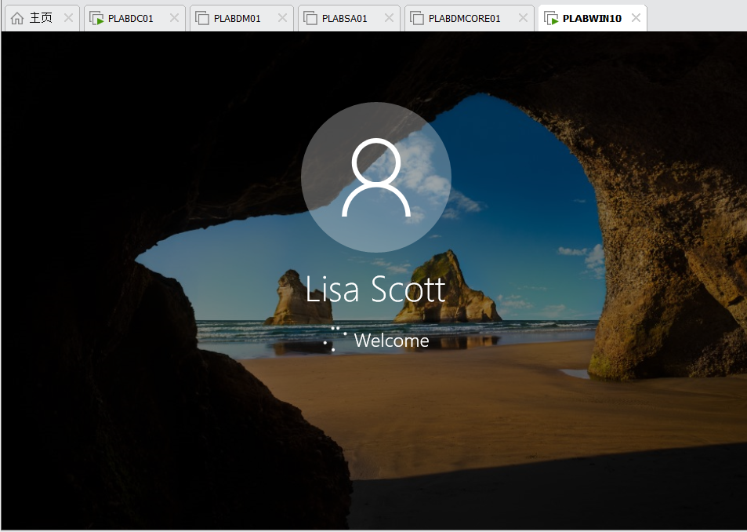

Figure 76 PLABWIN10 : Login as Lisa Scott

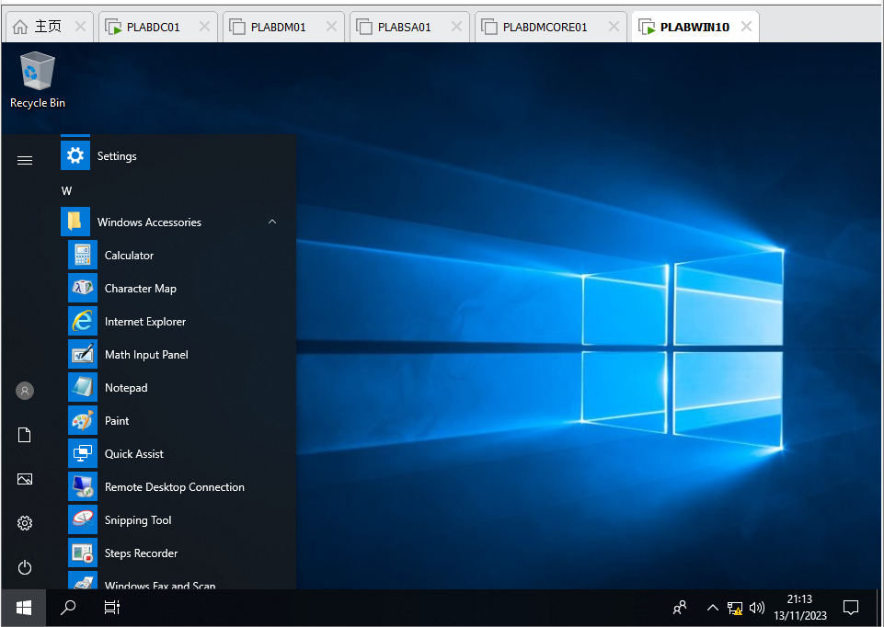

Figure 77 PLABWIN10 : Find the Notepad and try to launch it

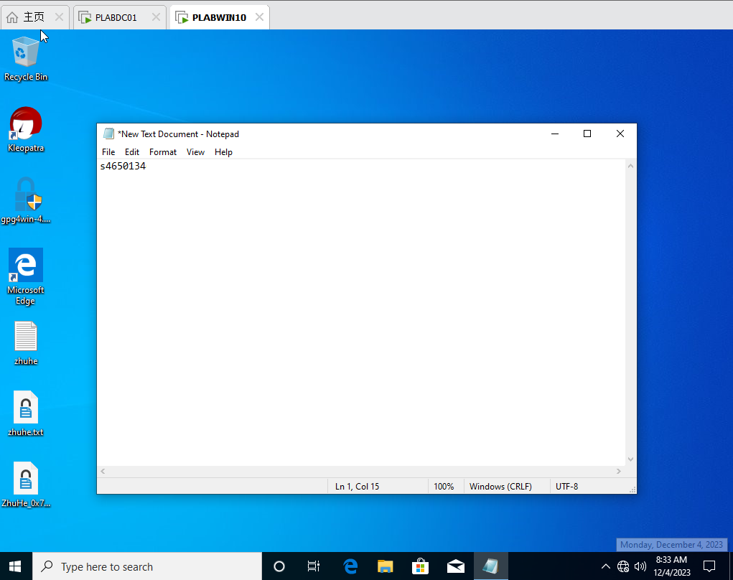

Figure78 PLABWIN10 : launch notepad.exe successfully

o Set **Lisa.Scott** as a member of **NIT3122CGO** and, then logon to verify the setting.

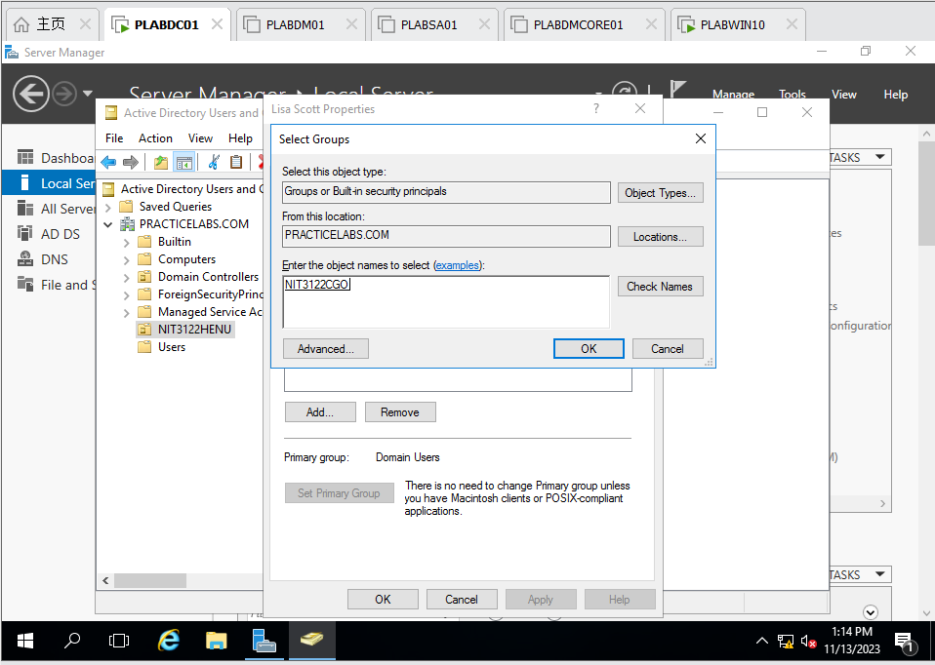

Figure 79 PLABDC01 : Add Lisa Scott to NIT3122CGO

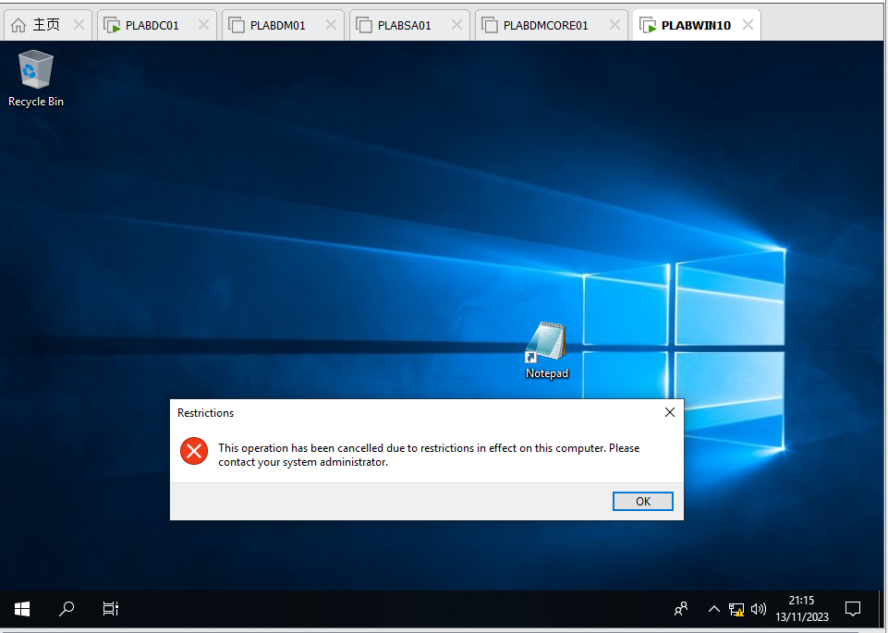

Figure 80 PLABWIN10 : Try to launch notepad and find it is prohibited because the Group policy prohibited

o Take screenshots of the above procedures and explain the results.

 Use commands **dates;ipconfig /all** to record the configurations, and take screenshots for each server/computer.

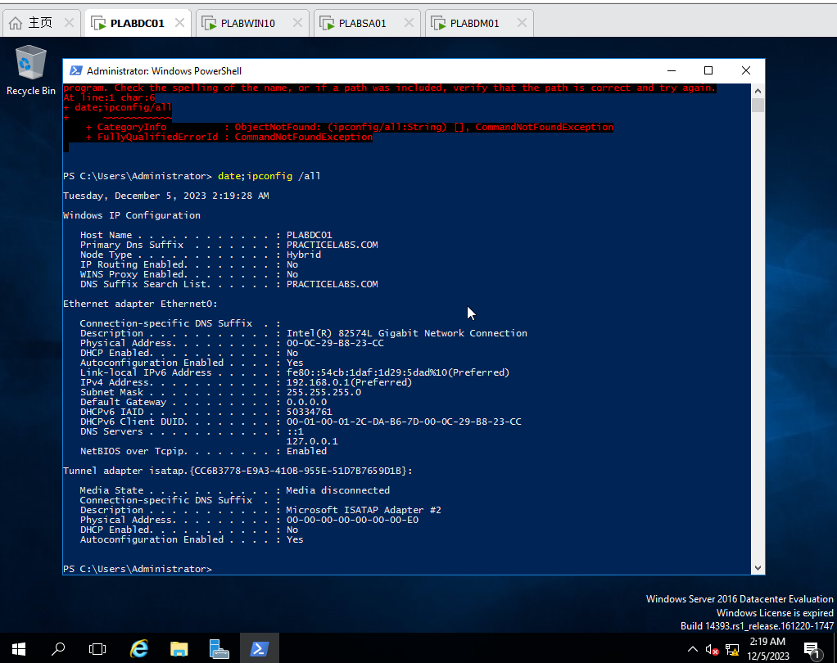

Figure 81 PLABDC01 : date;ipconfig /all

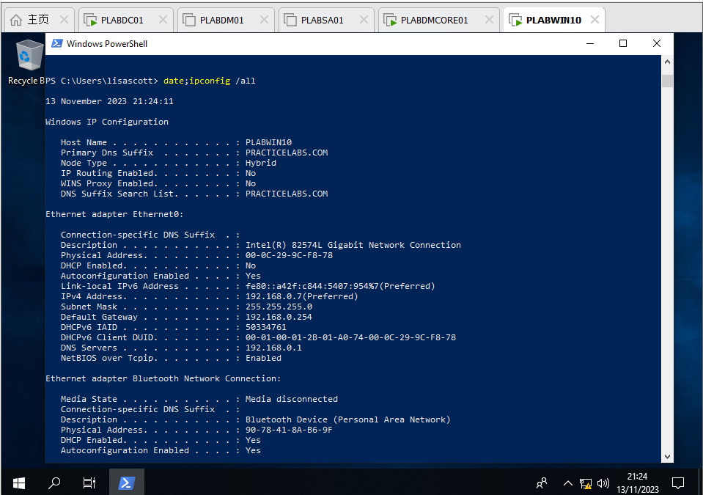

Figure 82 PLABWIN10 : date;ipconfig /all

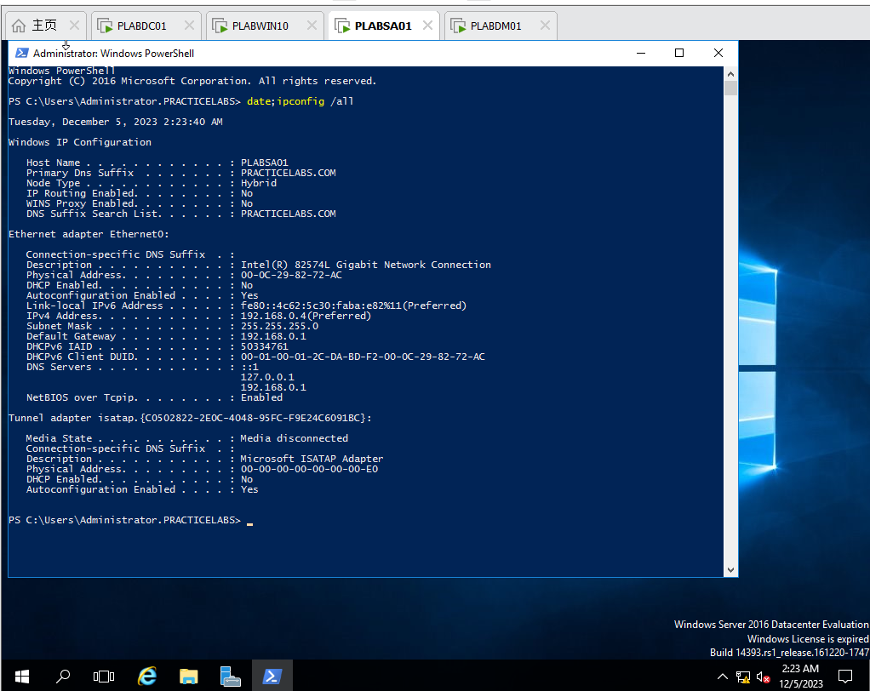

Figure 83 PLABSA01 : date;ipconfig /all

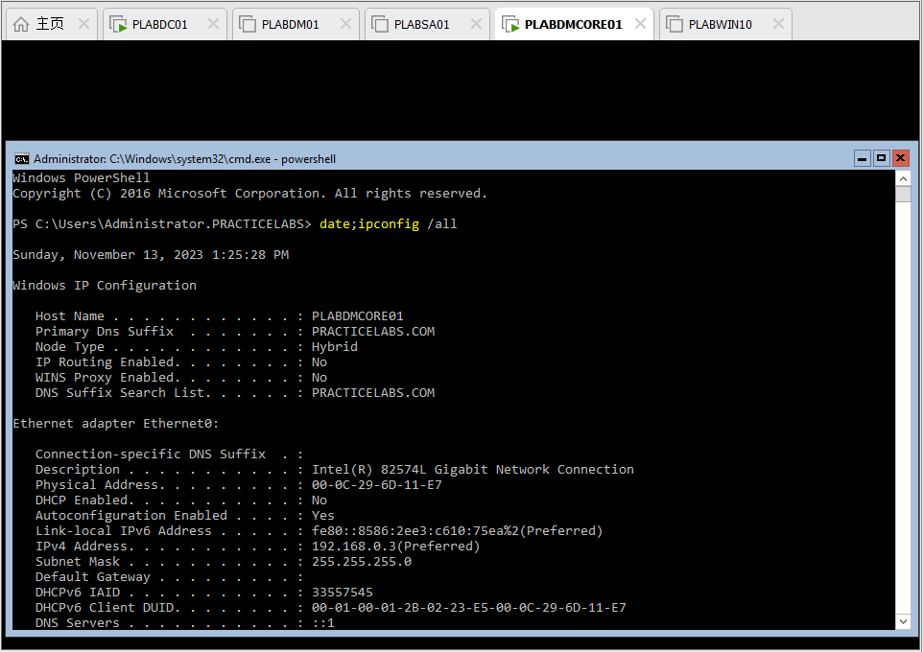

Figure 84 PLABDMCORE01 : date;ipconfig /all

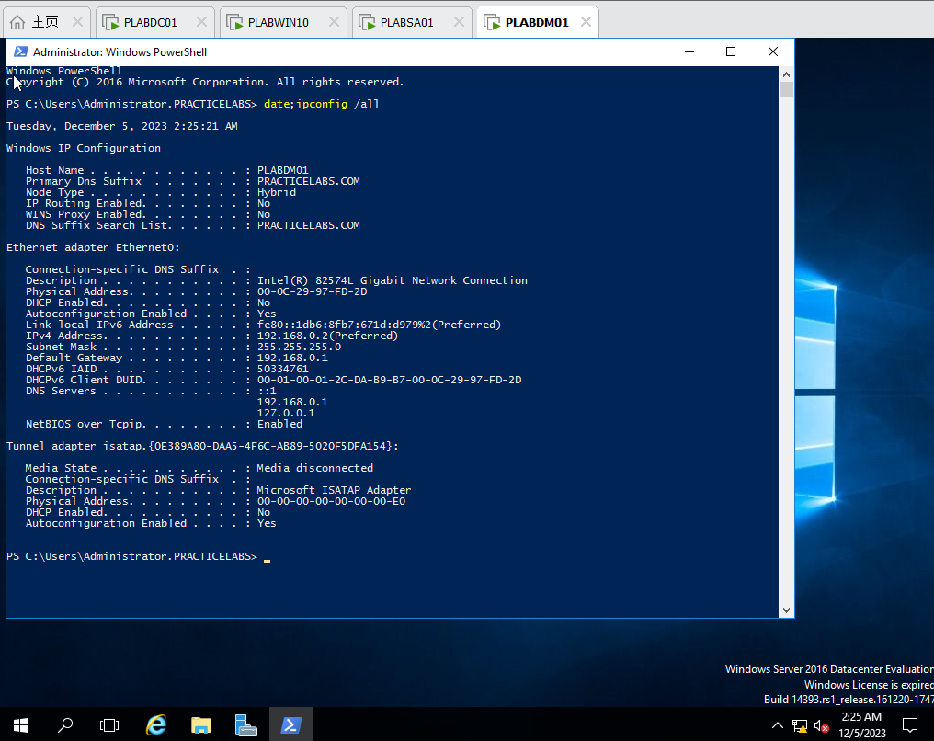

Figure 85 PLABDM01 : date;ipconfig /all

**Once you complete the Assignment**, log on VU Collaborate and upload your **Assignment_YourName_YourID.docx** via dropbox.